**FIT2100 - Notes**

[Condensed Notes](https://docs.google.com/document/d/1OEzrXeQo-nE6lNZeHqtXz2hHzCZ2ju8rVUp_EfZS_GU/edit?usp=sharing)

[Sample Midsem](https://drive.google.com/file/d/1kFRmrcE8K9qSOa8VW5nN6XJIQJ9wp-tL/view?usp=sharing) / [Sample Exam](https://drive.google.com/file/d/1GzfvXOG3GB5sy2_ClM-f8YsXATqJ_nnz/view?usp=sharing)

**Table of Contents**

Week 1 - Computer System Overview

Week 2 - Operating Systems Overview

Week 3 - I/O Management and Hard Drives

Week 4 - File Management

Week 5 - Processes

Week 6 - Uniprocessor Scheduling

Week 7 - Mid-Semester Test

Week 8 - Threads and Concurrency Part 1

8A Threads

8B Concurrency Part 1

Week 9 - Concurrency Part 2

Week 10 - Virtual Memory

Week 11 - Interprocess Communication

Week 12 - OS Security

# Week 1 - Computer System Overview

* **Central Processing Unit** 
  + A program interpreter is built into hardware, and it runs machine code
    - CPUs can only run instructions written in it’s own machine code:
      * **C -** compile into machine code before running on CPU
      * **Python -** interpreter reads instructions and does everything on your behalf - much slower to execute
  + Operates on the fetch-decode-execute cycle
    - Fetch information from memory (PC), decode and prepare sections of CPU needed for execution (IR), execute the instruction
      * Processor-Memory (load, store)
      * Processor-IO (system calls)
      * Data processing (arithmetic and logical)
      * Control (flow execution)
  + Consists of Registers, IR, PC, etc.
* **Memory**
  + Stores data and programs that have been loaded for execution
    - Program must be loaded into main memory before it can run (otherwise no fetch)
    - To access something in memory, you need to know it’s starting address, and how many bytes you need
* **System Bus**
  + Provides a means of communication among processors, main memory, and I/O via the address, data, and control bus
* **Interrupts**

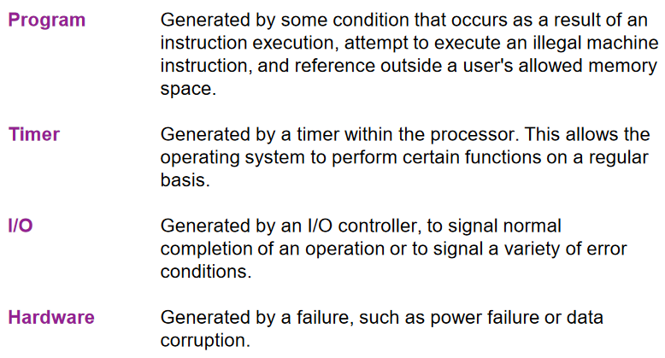

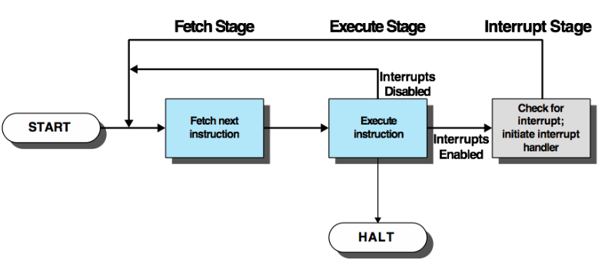

* + Normal sequence of processor interrupted to improve utilisation
* **Memory**
  + **Hierarchy**
    - **Closer to CPU** - smaller capacity but extremely fast
    - **Further away from the CPU** - higher capacity but slower
  + **Constraints**
    - Capacity
      * Higher amounts of lower hierarchy memory is cheaper (i.e. HDD storage)
        + Higher capacity means less cost per hit, but slower access speed
    - Speed
      * Keep up with the processor otherwise pipeline stalled
    - Expense
      * Reasonable in relation to other components
  + **Locality**
    - **Temporal and Spatial Locality**
      * Memory references by the processor tend to cluster
      * Data is organized so that the percentage of accesses to each successively lower level is less than that of the above
* **Cache**

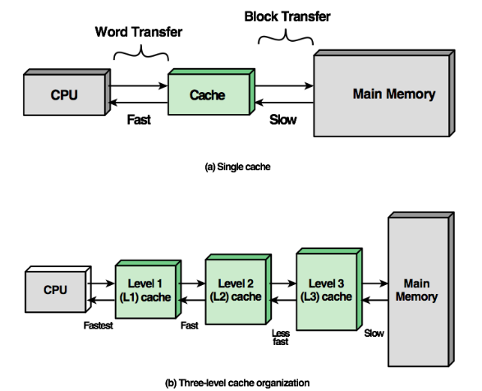

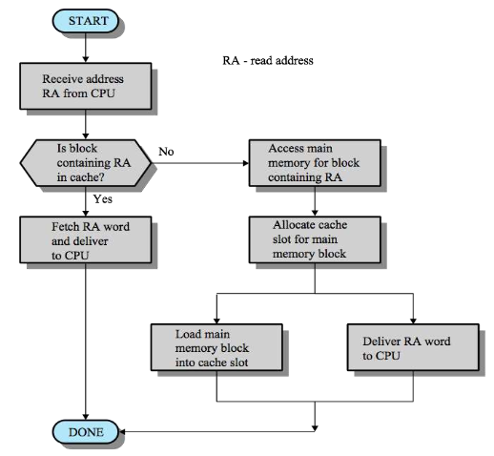

# Week 2 - Operating Systems Overview

* **Operating System (OS)**
  + A program that controls the execution of application programs
    - An interface between applications and hardware
  + **Objectives**:
    - Convenience
    - Efficiency
    - Ability to evolve
    - *Compatibility*
    - *Security*
  + **Key Terms**
    - **Resource Allocator -** manages and allocates resources to programs
    - **Control Program -** controls the execution of user programs and operation of I/O devices
    - **Kernel -** the one application running at at all times (all else being application programs)
      * Kernel is the part of the OS that can run all other OS and user programs
  + **OS Services**
    - User Interface
    - Program Execution
    - Program Development
    - Access I/O devices
    - Controlled access to files
    - System access
    - Error detection and response
    - Communication
    - Protection and Security
    - Accounting

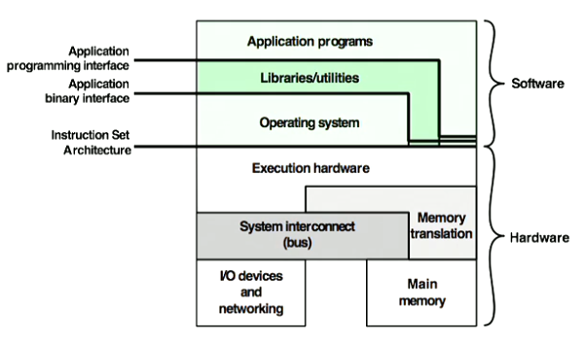

*Library / utilities are considered “systems programs”  
Application programs are considered “user programs”*

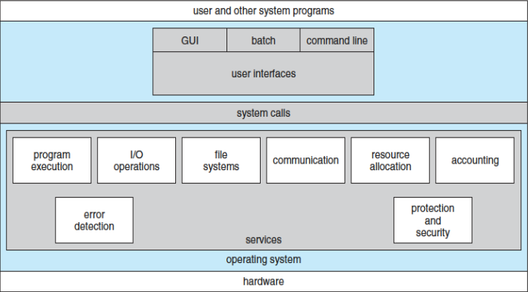

* + **System Calls?**
    - A way to access OS services directly
      * CPU jumps to code to carry out the service directly
        + e.g. read(), write(), open(), close()

These are a set of library functions in c

* + - The most primitive building blocks for more advanced functionality
      * The deepest way to access the OS on which high level functions are built
  + **Role of an OS**
    - Responsible for managing the computer's resources by being in control of the computer’s basic functions
      * “*OS provides instructions to the processor and directs the processor in terms of the use of other system resources and the timing of execution for other programs*”
    - The OS functions in the same way as ordinary software
      * Simply a suite of programs executed by the processor
      * Frequently context switches and must depend on the processor to allow it to regain control
    - “*The OS provides instructions to the processor and directs the processor in terms of the use of other system resources and the timing of execution for other programs*”
      * e.g. time slicing, etc.
* **Evolution of OS**

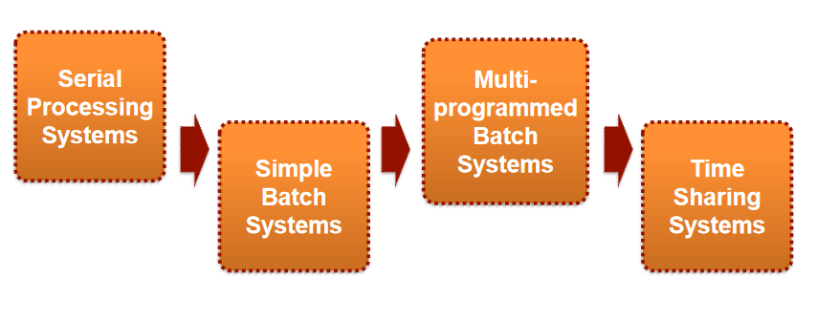

* + A major OS will evolve over time for a few reasons:
    - Hardware Upgrades
    - New Types of Hardware
    - New Services
    - Fixes
  + **Serial Processing Systems**
    - No OS - developers interacted directly with hardware
    - Users have access to the computer in “series”
    - **Problems**
      * Most installations used a hardcopy sign-up sheet to reserve computer time
      * Time allocations could run long or short, resulting in wasted computer time
      * Large amount of time spent just on setting up a program / job for execution
  + **Simple Batch Systems**
    - Important to maximise processor utilisation as early computers were extremely expensive

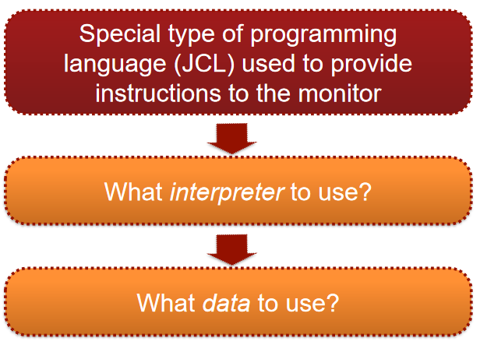

* + - * + “JCL” - job control language
    - The concept of “monitor”
      * Users no longer have direct access to processor
      * Jobs submitted to a computer operator who batch them together and places them onto an input device
      * Program branches back to monitor when finished
    - **User Mode**
      * User program executes in user mode
      * Certain areas of memory are protected from access
      * Certain instructions may not be executed
    - **Kernel Mode**
      * Monitor executes in kernel mode
      * Protected areas of memory can be accessed
      * Privileged instructions may be executed
    - **Overhead?**
      * Processor alternates between execution of user programs and execution of monitor
        + Some main memory is given over to the monitor
        + Some processor time is consumed by the monitor
      * Despite overhead, simple batch system improves utilisation
  + **Multiprogrammed Batch Systems**
    - Processor is often idle, even with automatic job sequencing
      * I/O devices in particular are slower compared to the CPU
    - **Uniprogramming**
      * Processor spends a certain amount of time executing until it reaches an I/O instruction
      * Must wait until the I/O instruction concludes before proceeding
    - **Multiprogramming: Two Jobs** 
      * When one job needs to wait for I/O, the CPU switches to the other job, which is likely not waiting for I/O

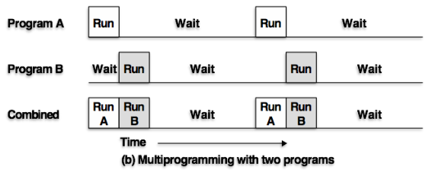

* + - **Multiprogramming: Three Jobs**
      * Memory is expanded to hold three, four, or more programs and switch among all of them
      * The concept of “multitasking”

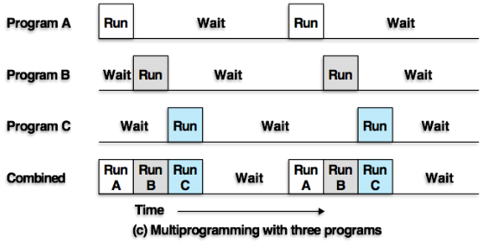

* + - **Effects on Resource Utilisation**

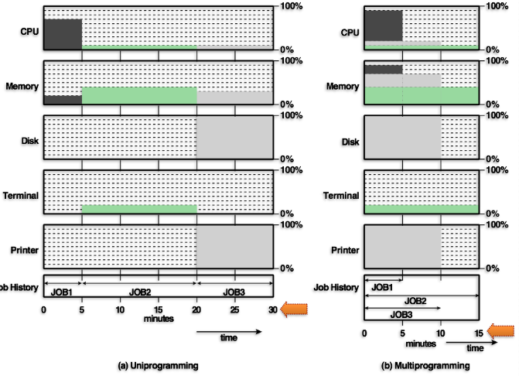

* + **Time-Sharing Systems**
    - Can be used to handle multiple interactive jobs by sharing the processor time among multiple users
      * Multiple users simultaneously access the system through terminals, with the OS interleaving the execution in a short burst or “quantum” of computation
        + aka, “time splicing”
    - The principal objective is to minimise response time
* **Major Advances in OS Development**
  + *Processors, Memory Management, Information Protection and Security, Process Scheduling and Resource Management*
  + **Processes**
    - A process is fundamental to the structure of an OS
      * A unit of activity characterised by a single sequential thread of execution, a current state, and an associated set of system resources
    - Three major lines of computer system development created problems in timing and synchronisation
      * **Multiprogramming Batch Operation** - switched among the various programs
      * **General Purpose Time Sharing** - responsive to the individual users but be able to respond to multiple users simultaneously
      * **Real-Time Transaction Processing Systems** - number of users entering queries or updates against a DB.
    - **Key Components**
      * Executable Program
      * Associated Data needed by the program (e.g. variables, buffers, etc.)
      * **Execution Context** (or process state) of the program
        + The internal data by which the OS is able to control the process
        + The contents of various process registers
        + Other information such as the priority of the process, if it is waiting on I/O, etc.

* + **Memory Management**

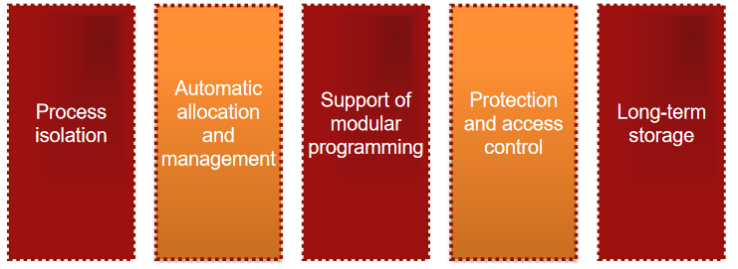

* + - Achieved by virtual memory and file system facilities
  + **Information Protection and Security**
    - The nature of the threat that concerns an organisation will vary greatly on circumstances
    - The concern involves controlling access to computer systems and the information stored in them
      * **Availability**
        + Computer needs to actually function to be useful
      * **Confidentiality**
        + Users cannot read with other users private information
      * **Data Integrity**
        + Users cannot interfere, edit, or delete other users private information
      * **Authenticity**
        + Users cannot create or interfere with other users private information
  + **Scheduling and Resource Management** 
    - Key responsibilities of an OS is managing various system resources (main memory, I/O devices, processors)
    - Resource allocation and scheduling must consider
      * **Fairness -** equal and fair access to resources by competing processes
      * **Differential Responsiveness -** discriminate among different classes of processes
      * **Efficiency -** maximise throughput and minimise response time; accommodate as many users as possible
        + **Throughput -** how many processes, on average, can be completed in a certain time period
* **OS Architecture for Unix / Linux** 
  + **Architecture**

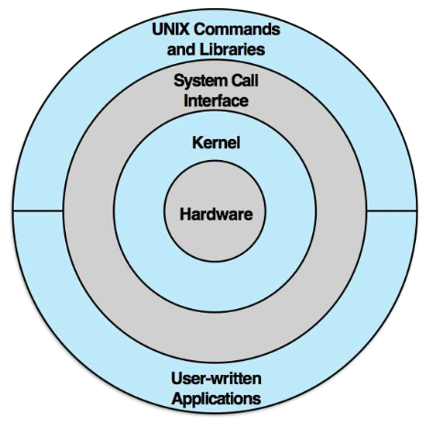

* + **Kernel (Traditional)**

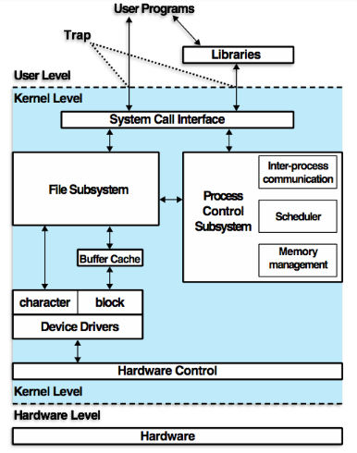

* + **Kernel (Modern)**

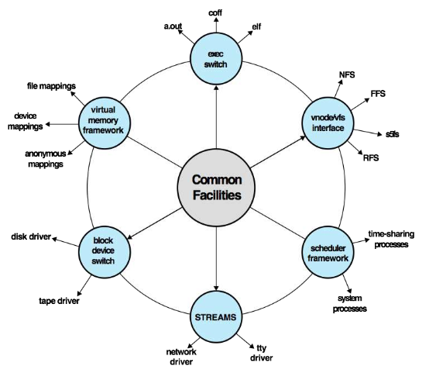

* + **Linux Systems**
    - Started as a UNIX variant for IBM PCs - a fully featured UNIX system that runs on several platforms
    - Highly modular and easily configured
    - Free, with source code available under GNU

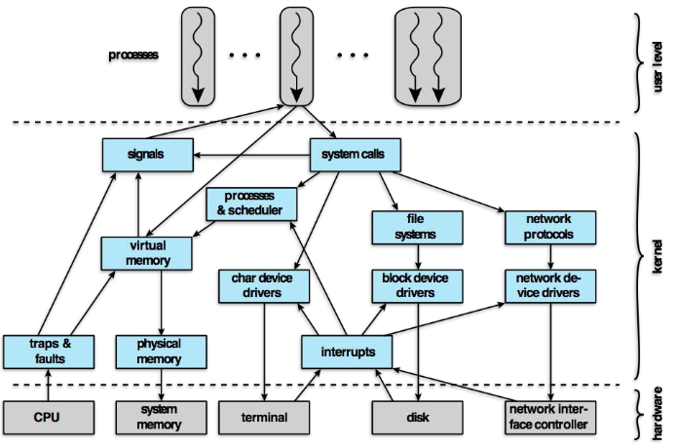

# Week 3 - I/O Management and Hard Drives

* **I/O Devices**
  + **Categories**
    - **Human Readable**
      * Suitable for communicating with computer users
      * Printers, terminals, video display, keyboard, mice
    - **Machine Readable**
      * Suitable for communicating with electronic equipment
      * Disk drives, USB keys, sensors, controllers, actuators
    - **Communication**
      * Suitable for communicating with remote devices
      * Modems, digital line drivers, wireless interface cards
  + **Data Rates**

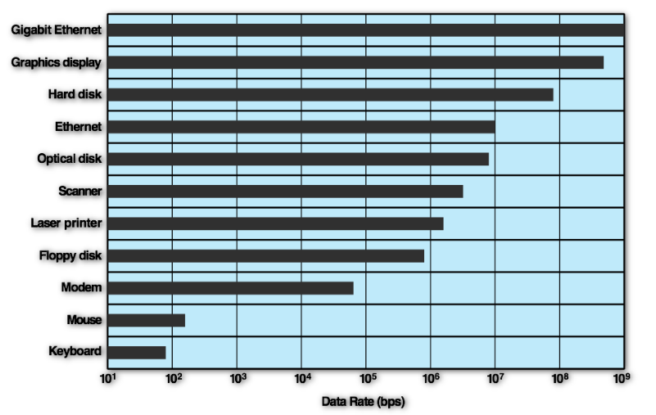

* + **Logical Structure**

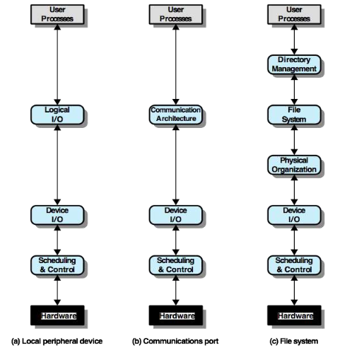

* + **Techniques**

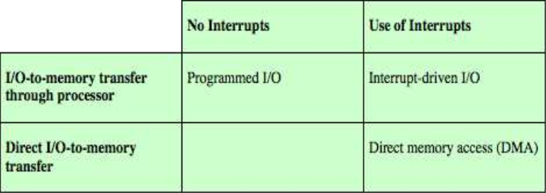

* + - **Programmed I/O**
      * The processor issues an I/O command on behalf of a process to an I/O module - the processor then **busy waits** for the I/O operation to be completed
        + **Busy Wait -** no interrupts allowed
      * **Basic Operations**
        + Processor requests an I/O operation
        + I/O module performs the operation
        + I/O module sets status bits
        + Processor checks status bits periodically - I/O module **does not** inform processor directly
        + Processor may wait or come back later
    - **Interrupt-Driven I/O**
      * The processor issues an I/O command on behalf of a process:
        + **Non-Blocking**

The processor continues to execute instructions from the process that issued the I/O command

* + - * + **Blocking**

The next instruction the processor executes is from the OS, which will put the current process in a blocked state and schedule another process

* + - * **Basic Operations**
        + Processor requests a read operation
        + I/O module gets data from I/O device while processor does other work
        + I/O module interrupts processor when data is ready for transfer
        + Procesor requests the data from I/O module
        + I/O module transfer the data to processor
    - **Direct Memory Access (DMA)**

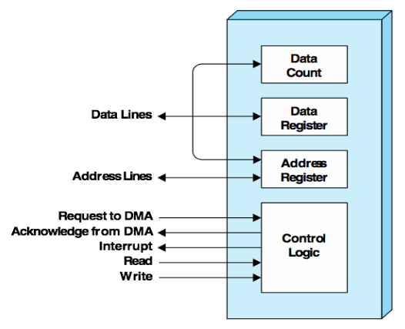

* + - * DMA module controls the exchange of data between the main memory and an I/O module (through system bus)
      * **Basic Operations**
        + Processors ends DMA a request for the transfer for a block of data
        + Processor continues with other work
        + DMA is responsible for transferring data to and from memory
        + Processor is interrupted only after the entire block has been transferred
      * **How does it work?**

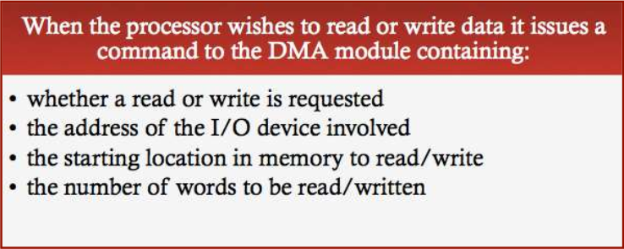

* + - * + DMA transfers the entire block of data directly to and from memory without going through the processor
        + When the transfer is complete, DMA sends an interrupt signal to the processor
        + Processor is involved only at the beginning and the end of the transfer
        + More **efficient** than interrupt-driven or programmed I/O
* **I/O Buffering**
  + **Overview**
    - Perform **input transfers in advance** of requests being made and perform **output transfers some time** after the request is made

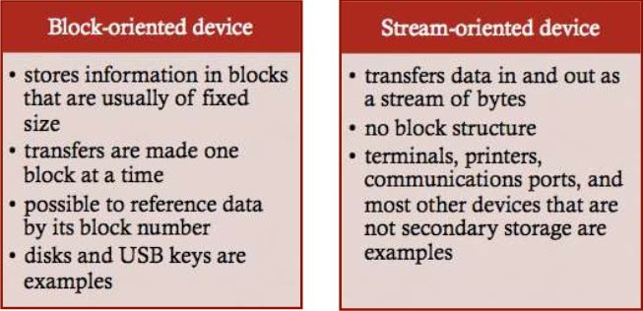

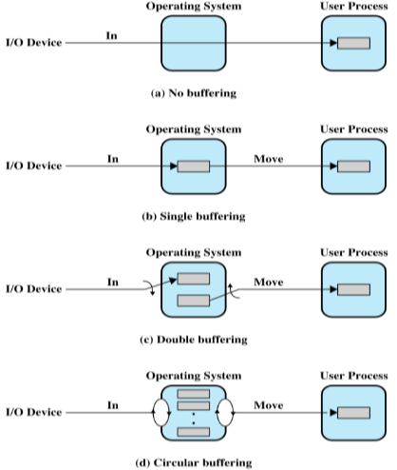

* + **Why do we use buffering?**
    - Buffering smoothes out peaks in I/O demand
      * “Read at a more civilised pace”
    - With enough demand eventually all buffers become full and their advantage is lost
    - When there is a variety of I/O and process activities to service, buffering can **increase the efficiency of the OS**, as well as the performance of the individual processes (multi-programming environment)
      * Reading stuff into a buffer allows you to do other things rather than just centrally focus on read/write
  + **No Buffer**

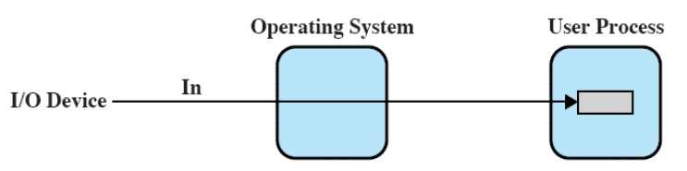

* + - Without buffer, the OS directly access the device when it needs to
      * Issue in multi-tasking systems; not all processes are in memory at a time, so this doesn’t always work
  + **Single Buffer**

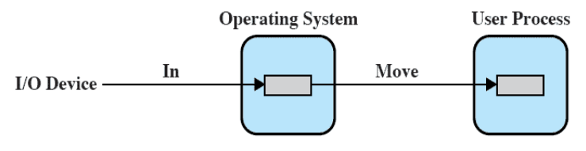

* + - When a user process issues an I/O request, **OS assigns a buffer** in main memory for an I/O request
      * Store on behalf of a process so it can read it when it needs to
    - **Block-Oriented Single Buffer**
      * Input transfers are made to the system buffer
        + **Reading Ahead or Anticipated Input**

With the expectation that the block will eventually be needed

When the transfer is complete, the process moves the block into user space (memory application) and immediately requests another block

* + - * + Generally this provides a speedup compared to the lack of system buffering

The user process can be processing one block of data while the next block is being read in

* + - **Stream-Oriented Single Buffer**
      * **Line at a time**
        + Appropriate for scroll-mode terminals
        + User input is one line at a time, with a carriage return signaling the end of a line
        + Output to the terminal is similarly one line at a time
      * **Byte at a time**
        + Used on forms-mode terminals
        + When each keystroke is significant
        + Interaction between OS and user processes follows the producer-consumer model
  + **Double Buffer**

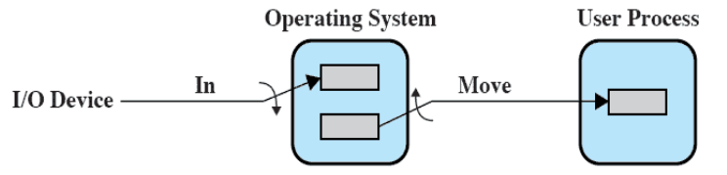

* + - Use two system buffers instead of one
      * While one is being filled up with input, the other is being read out to user space
        + When empty, swap them and work in reverse
    - A process can transfer data to or from one buffer while the operating system empties or fills the other buffer
    - Also known as **buffer swapping**
  + **Circular Buffer**

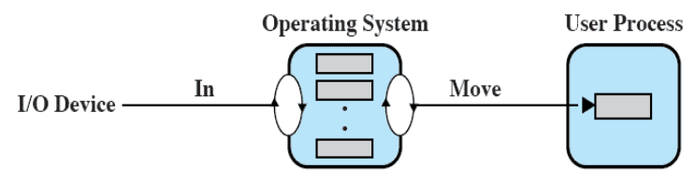

* + - Two or more buffers are used, with each individual buffer being one unit in a circular buffer
      * Basically just an expanded Double Buffer, reading in and out in order and rotating between empty, filling, and full buffers
    - This approach is used when I/O operation must keep up with the process
* **Disks**

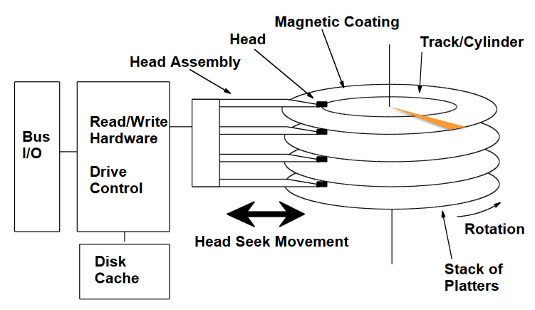

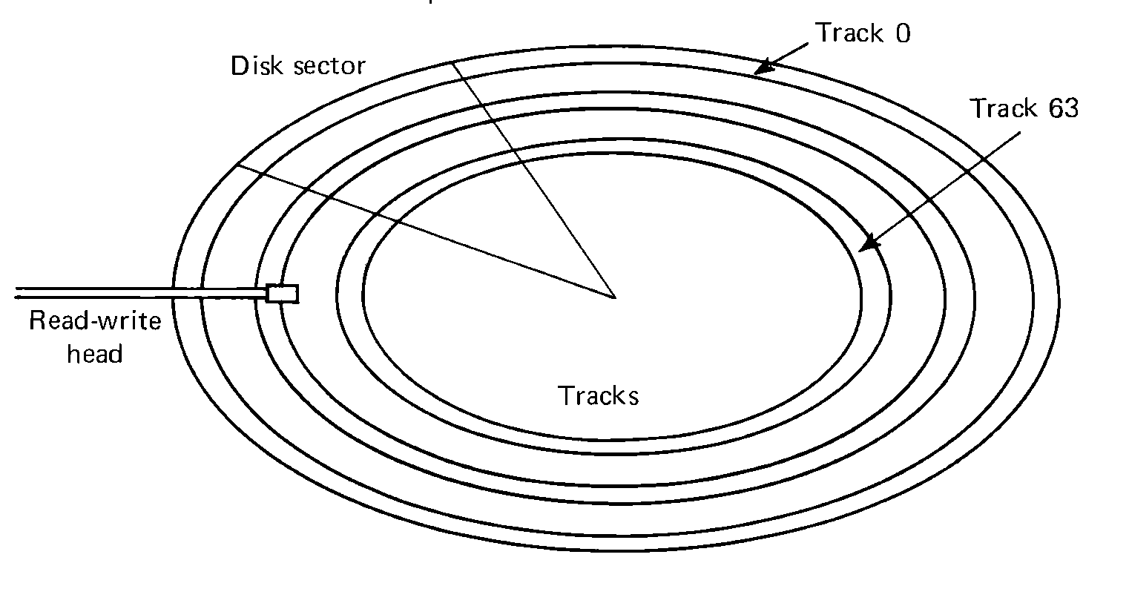

* + **Read/Write: Disk Head Position**
    - When the disk drive is operating, the disk is rotating at a constant speed
      * To read or write, the head must be positioned at the desired track, and at the beginning of the desired sector on that track
      * **Track Selection -** involves moving the head in a moveable-head system or electronically selecting one head on a fixed-head system
      * **Seek Time -** the time it takes to position the head (disk arm) at the track on a moveable-head system
      * **Rotational Delay -** the time it takes for the beginning of the sector to reach the head
      * **Access Time -** the sum of the seek time (if any) and the rotational delay
  + **Parameters**
    - The actual details of disk I/O operation depends on the:
      * Computer system
      * Operating system
      * Nature of the I/O channel and disk controller hardware

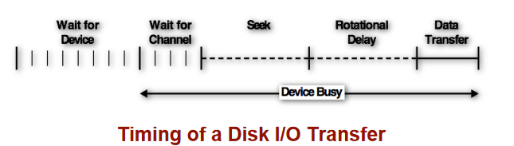

* + **Algorithms**

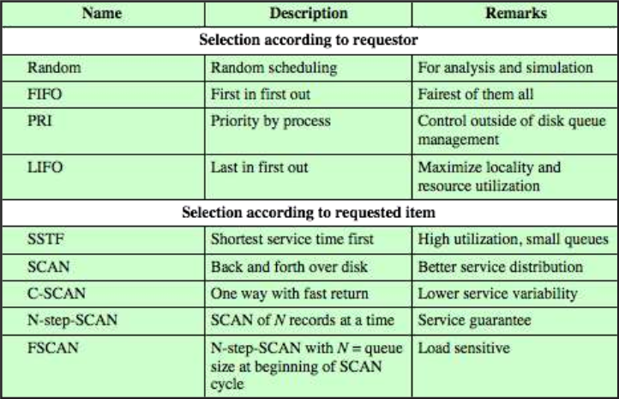

* + - **FIFO**
      * Processes in sequential order, making it fair to all processes
      * Approximates random scheduling in performance if there are many processes competing for the disk
    - **PRI (Priority)**
      * **Goal**: not to optimise disk utilisation, but to meet other OS objectives
      * Control of scheduling is outside the control of disk management software
      * Short batch jobs and interactive jobs are given higher priority
      * Provides good interactive response time
      * Longer jobs may have to wait an excessively long time
    - **SSTF (Shortest Service Time First)**
      * Select the disk I/O that requires the least movement of the disk arm from its current position (locality)
      * Always chooses the minimum seek time, meaning that it may cause new requests to “starve”
    - **SCAN (Elevator Algorithm)**
      * The disk arm (head) moves in one direction only
      * Satisfies all outstanding requests until it reaches the last track in that direction, at which point the direction is reversed
      * Favours jobs whose request are for tracks nearest to both innermost and outermost tracks
    - **C-SCAN (Circular SCAN)** 
      * Restricts scanning to one direction **only**
      * When the last track has been visited in one direction, the arm is returned to the opposite end of the disk, and the scan begins again
        + This reduces the delay experienced by new requests
* **Disk Cache**

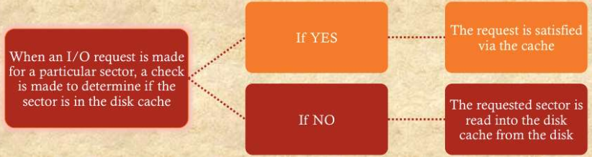

* + **Cache Memory** - smaller memory that is faster than the main memory and is placed between the main memory and the processor
    - Reduces access times by exploiting locality
    - **Disk Cache** - a buffer in main memory for disk sectors
      * Newer hard drives also come with a level of disk cache built in
      * Contains a copy of some of the sectors on disk
  + **Cache Block Replacement** 
    - **Least Recently Used (LRU)**
      * Most commonly used algorithm for dealing with the issue of replacement strategy
      * The block that has been in the cache for the **longest with no reference** is replaced
      * A stack of pointers reference the cache:
        + Most recently referenced block is on top of the stack
        + When a block is referenced or brought in to the cache, it is placed on top of the stack
    - **Least Frequently Used (LFU)** 
      * The block that has experienced the fewest references is replaced
      * A counter is associated with each block, and is incremented each time the block is accessed
      * When replacement is required, the block with the smallest count is selected
* **I/O Management in Unix**

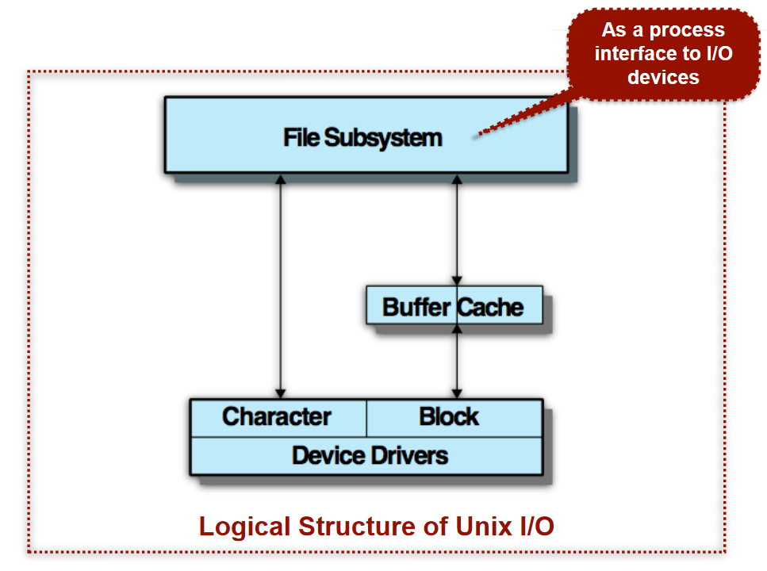

* + **What is a driver?**
    - Program code embedded in OS that provide an interface for interacting with a hardware device
    - In Linux, driver interfaces appear as virtual “files” in the /dev/ directory
      * These files can be written to or read from in order to access / modify hardware devices
  + **Buffer Cache**
    - I/O operations with disk are handled through the buffer cache - disk cache
    - Data transfer between the buffer cache and the user process space always occurs using DMA
      * Does not use up any processor cycles, but does consume bus cycles
    - Three lists are maintained (each slot holding one disk sector / 512b)
      * **Free List** - a list of all slots in the cache that are available for allocation
      * **Device List** - a list of all buffers currently associated with each disk
      * **Driver I/O Queue** - a list of buffers that are actually undergoing or waiting for I/O on a particular device

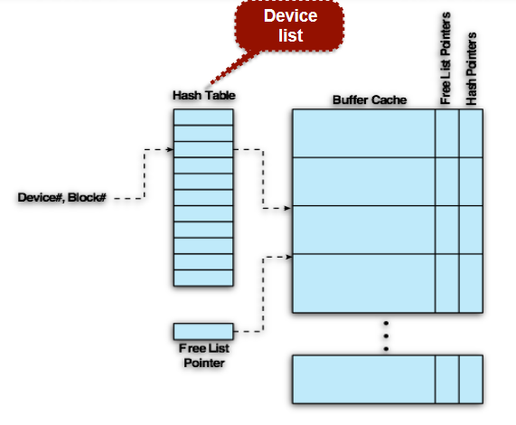

* + **Character List (stream device)**

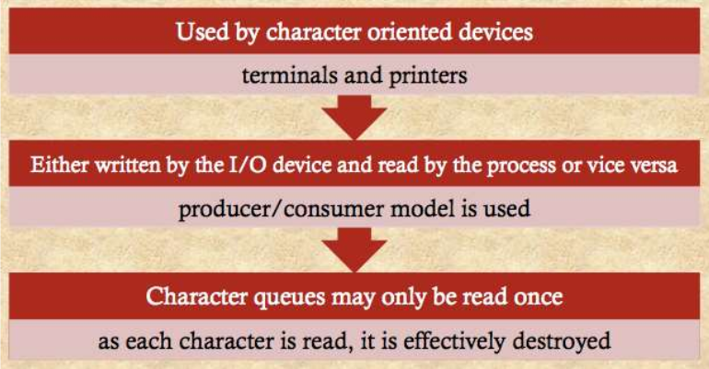

* + **Unbuffered I/O**
    - Simply **DMA** **between device and process spare**
    - Always the fastest method for a process to perform I/O
    - Process is locked in main memory and cannot be swapped out
      * I/O device is tied up with the process for the duration of the transfer (unavailable for other processes)

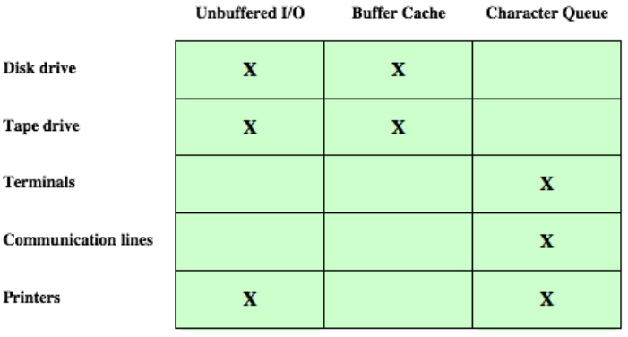

# Week 4 - File Management

* **What is a file?**
  + A file is a sequential list of characters (bytes), with interpretation of the data being determined by the application program
    - **Text File**
      * File is made up of characters, with each byte being assigned a character code value
      * When printing the file contents, the terminal displays actual characters
    - **Binary File**
      * Bytes are used to store values directly
        + e.g. 4 bytes use to represent a 32 bit integer
        + One bytes can store a value from 0 to 255 (28 - 1)
      * Binary files as text show nonsense characters as byte values do not need to match readable character codes
* **What is a filesystem?**
  + **Software within the Operating System**
    - Manages data on the disk (translates block data on the disk into the abstract concept of files and directories)
    - Provides services for accessing and manipulating files
  + **Structured Data stored on the Disk itself**
    - Multiple approaches
    - Different operating systems use different file systems
      * Two most common approaches are File Allocation Tables (Windows), and Inode-based systems (UNIX)

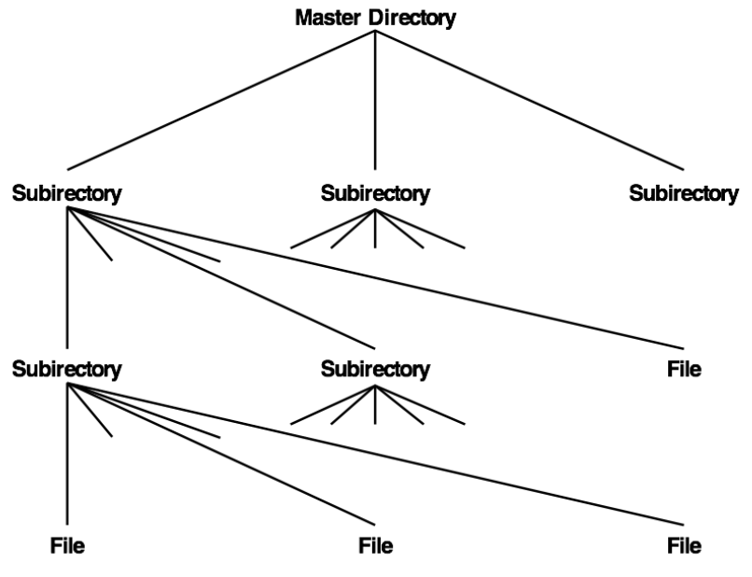

* + **Hierarchical File Systems**
    - aka “Tree-Structured Directory”
    - Multiple file-organisation approaches are possible
      * Tree-structured or ‘hierarchical’ is most common
    - A root directory or ‘master directory’ contains files and sub-directories
  + **Real-World File Systems - FAT**

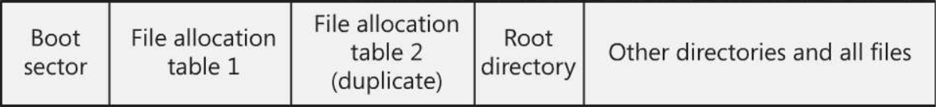

* + - “File Allocation Table” is common on Windows systems
    - Drive is split into equal sized blocks (FAT32 - 1TB HDD split into 32k ‘clusters’)
      * A file may occupy one or more blocks
    - A table at the start of the disk contains an entry for every block on the drive
      * If the table is corrupted, files can no longer be located
      * Two copies of the table are kept, for redundancy
    - **Fragmentation**
      * **External**
        + Free blocks between files, but the spaces are not large enough to fit certain files

e.g. delete small file, leaving a space that is too small to be occupied by a larger file

* + - * + Fragments of wasted space unless the file can be split over multiple fragments
        + Was a big problem in old file systems
      * **Internal**
        + If a file is smaller than a single block, there is unused space inside the block that cannot be allocated to other files
    - **How does a directory work in FAT?**

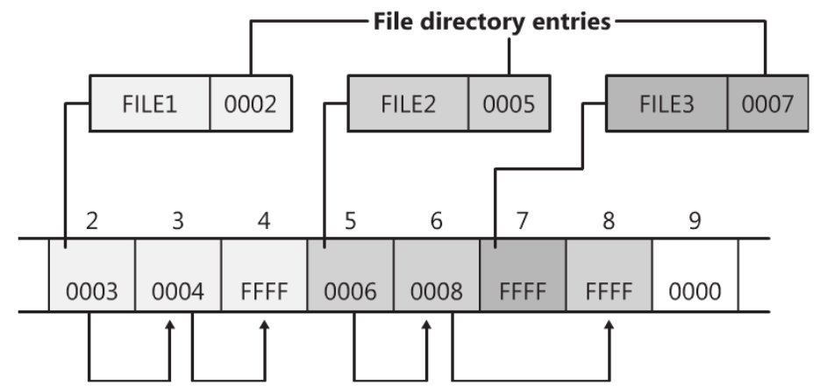

* + - * Filenames are stored with their starting block, which form linked lists
        + The file named “FILE1” starts at block 2, and continues at block 3, and continues at block 4

FFFF is a special character that notes the end of a file

* + - * A directory stores the address of the starting block of each file, with files being allocated to the first empty block
      * If a file is too large for one cluster, available clusters are chained together
        + Each block stores a reference to the next one where the file continues
        + By following the chain, the entire file can be read
    - **File System Aging**
      * **No External Fragmentation**
        + Chaining blocks together means that no blocks are wasted, and that files do not need to be contiguous on disks

Files are added and deleted, creating gaps of free sectors

* + - * A large file may not fit into a single gap, and this must be spread over different tracks (degrading access time)
      * Disk requires periodic defragmentation to improve performance, whereby files are rearranged into contiguous blocks
  + **Real-World File Systems - Unix Inodes**
    - In Unix, everything(™) is a file
    - **Types of files in Unix**

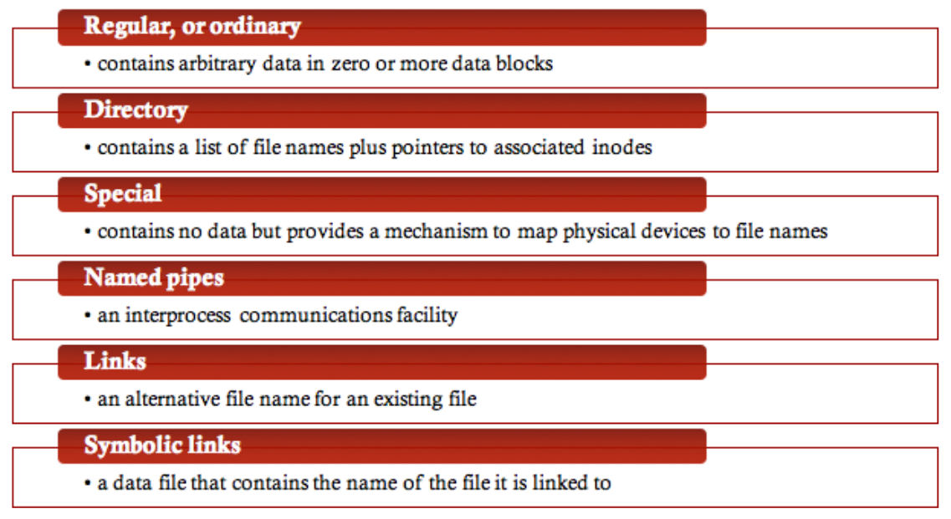

* + - **Inodes**
      * All types of Unix files are stored in a table of inodes (index nodes)
        + The inode for a file stores key information about the file, with each file being controlled by exactly one inode
        + Several filenames can be mapped to a single inode

The same physical file can be mapped to multiple directories

* + - **How does a directory work in Inode-based filesystems?**
      * A directory is stored like a regular file
      * Directory contains a table of inode numbers and filenames
      * Files are located by looking up the appropriate inode in the inode table

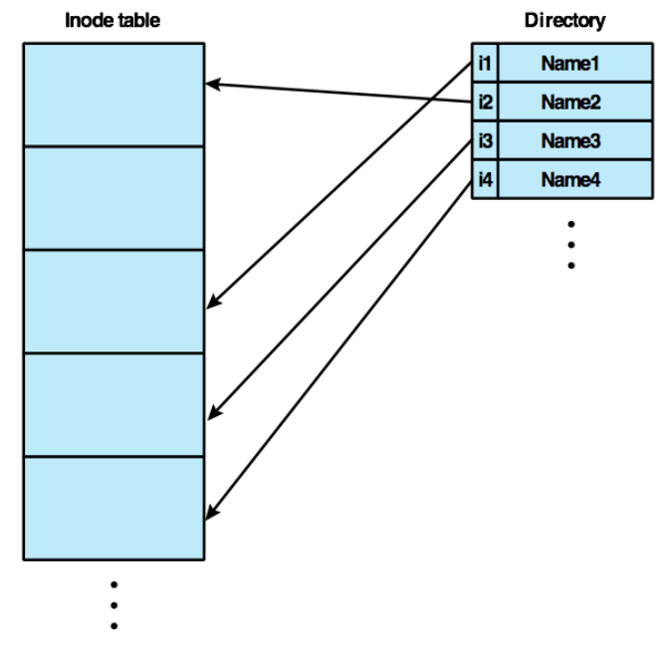

* + - **File System Structure**
      * Each inode contains various information about a file, and how to locate it on disk
        + When a file is opened, its corresponding inode is loaded into main memory
      * If a file requires 12 blocks or less on disk, these addresses are listed directly in the inode itself
      * If a file is larger than 12 blocks, the file system allocates special pointer blocks containing the remaining addresses
        + If the file is very large, multiple levels of pointer blocks are used

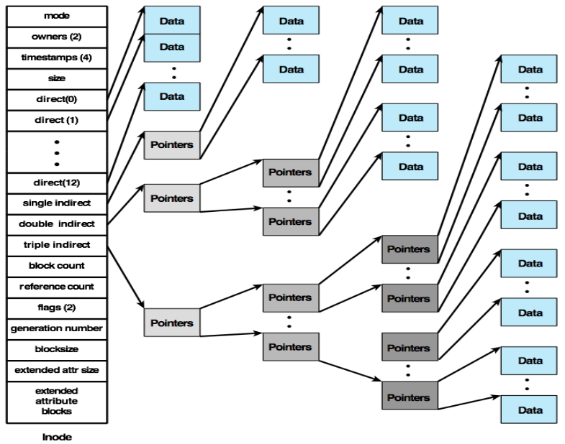

* **Booting the Operating System**
  + aka “bootstrapping”
  + **A Problem**
    - Before the computer is turned on, the OS exists only on the HDD - but how do you locate files on the HDD without the OS running?
      * **Solution - Bootstrapping**
        + Use a very small, primitive system to start up a more advanceds system
  + **BIOS (Basic Input Output System)**
    - **EEPROM - Electrically Erasable Read Only Memory**
      * Very small area at the end of main memory that is read only, and contains machine code when the power is turned on
        + The CPU always looks here for the first code to execute, which contains instructions for recognising connected hard drives
        + Can remember hard drive configuration using a small battery inside the computer.
      * Does not need to know how to read a filesystem, only how to read bytes from HDD to memory
        + Points to MBR
    - **Master Boot Record (MBR) / Boot Sector**
      * **Track 0, Sector 0**
        + The first 512 bytes on a bootable hard drive, containing machine code known as the “bootstrap program”

**The MBR is not a ‘file’**

If the OS hasn’t loaded yet, there are no services for locating files on the rest of the drive

Therefore exists independently of the file system

Just raw bytes read directly from the start of the hard drive

* + - * + The computer’s BIOS loads ths into main memory and points the CPU to it
        + Contains instructions for locating and loading the kernel, which loads the rest
* **Accessing the filesystem in Linux** 
  + **System Calls**
    - **open()**
      * OS allocates a number (file descriptor) to each open file within a running process (and keeps track of the current read / write position)
    - **write()** 
      * The program tells the OS the starting address in main memory and how many bytes to write into the file
    - **read()** 
      * Program gives the OS a main memory address to read file contents into, and how many bytes may be read into memory
      * The OS increments position after each read / write.
    - **lseek()**
      * The OS changers the current read / write position to a different place within the file
    - **close()** 
      * The OS de-allocates the file descriptor information from memory
* **File Allocation Styles**
  + **Contiguous** 
    - **External Fragmentation**

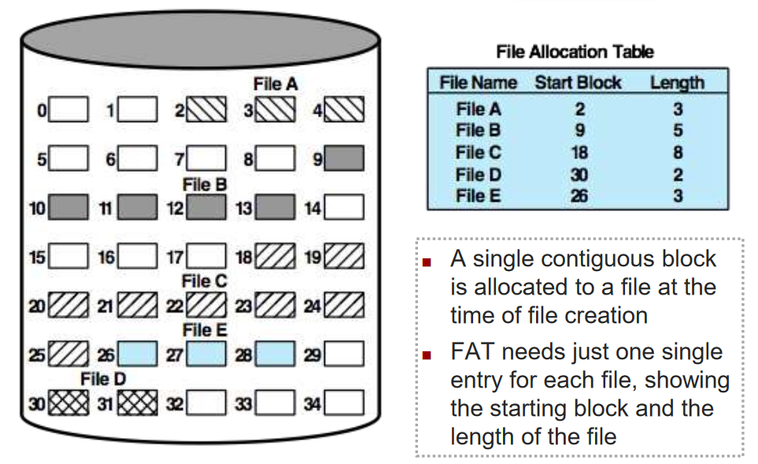

* + - **No Fragmentation**

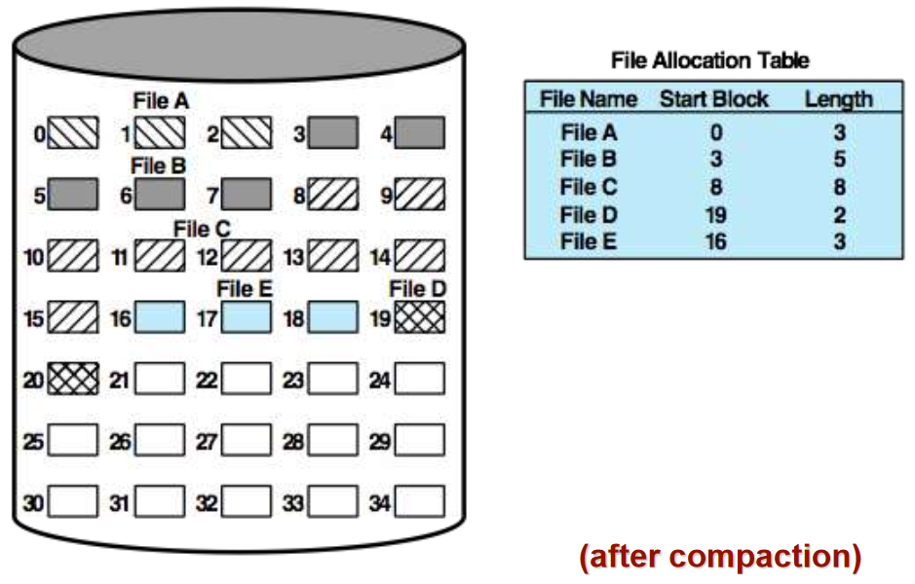

* + **Chained** 
    - **No Fragmentation**

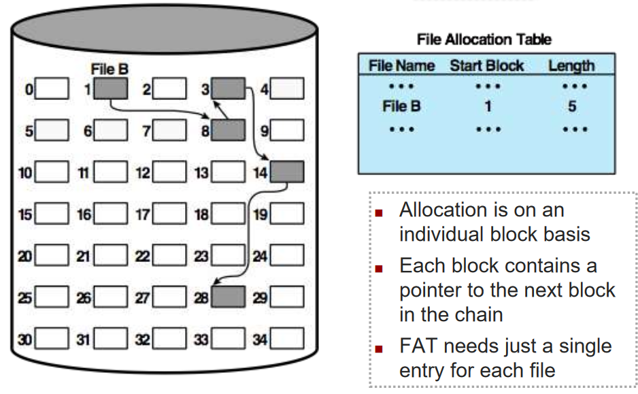

* + - **No Accomodation for Locality**

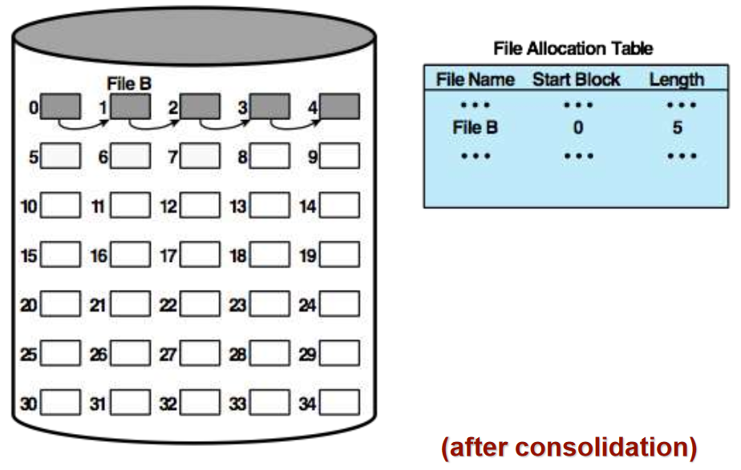

* + **Indexed with Block Portions**
    - Eliminates external fragmentation

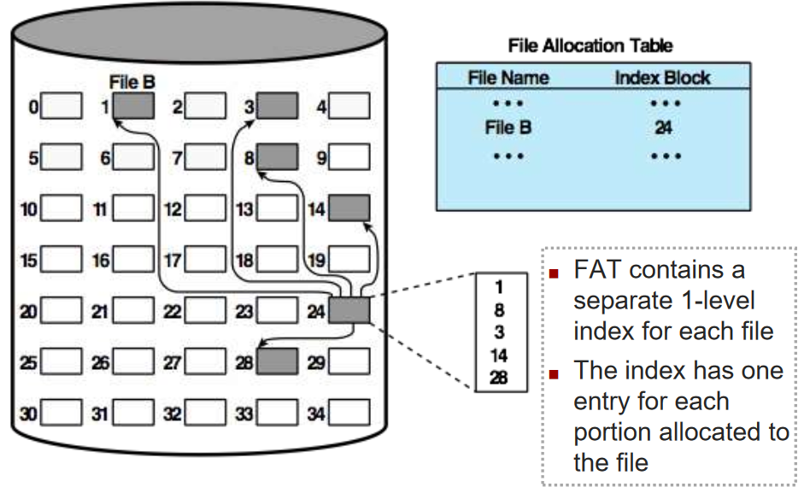

* + **Indexed with Variable-Length Portions**
    - Improves locality
    - Indexed allocation supports both sequential and direct access to file

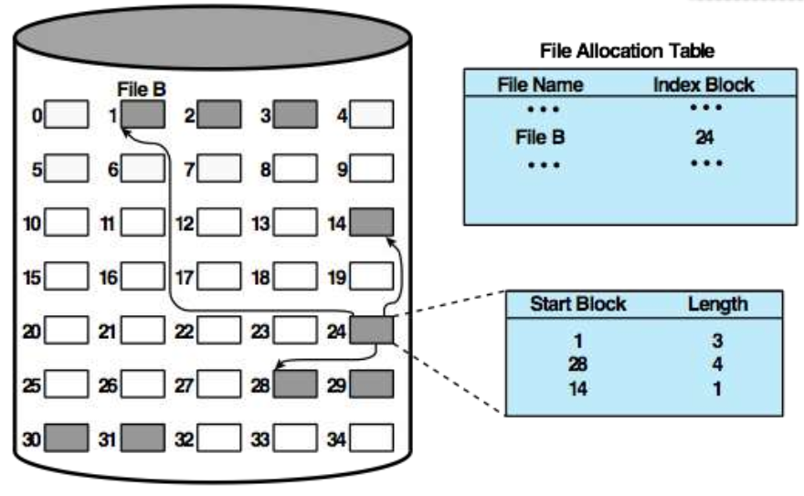

# Week 5 - Processes

* **OS Management of Application Execution**
  + System resources are made available to multiple applications (multiprogramming / multitasking)
  + The processor is switched among multiple applications such that all will appear to be progressing (time splicing of processor time)
  + The processor, memory, and I/O devices can be used efficiently
* **Typical Functions of the OS Kernel**

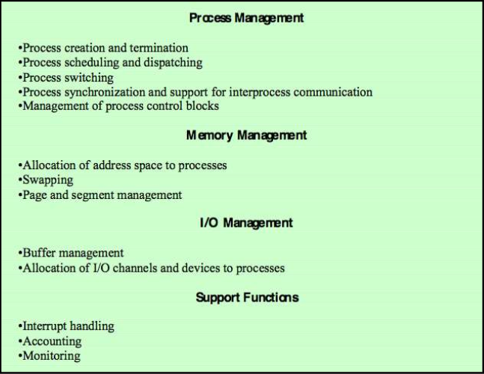

* **Process**
  + **The Concept of Process**
    - Fundamental to the structure of operating systems

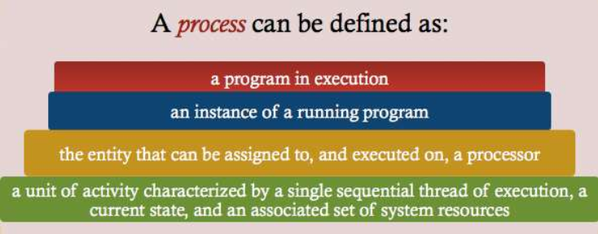

* + **Elements of a Process**
    - **Program Code -** may be shared with other processes that are executing the same program
      * When the processor begins to execute the program code, this executing entity is referred to as a **process**
    - **Data -** a set of data associated with the program code
  + **Attributes**
    - While the program is executing, the process can be uniquely characterised by a number of elements:
      * Identifier
      * State
      * Priority
      * Program Counter
      * Memory Pointers
      * Context Data
      * I/O Status Information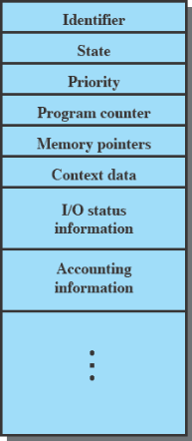
      * Accounting Information
  + **Process Control Block (PCB)** 
    - Data structure - contains the process elements
    - Created and mapped by the OS, it is the key tool supporting multiprocessing
    - Interrupt a running process is possible - later resume execution as if nothing happened
    - **Process = Program Code + Data + PCB**
* **Program Execution** 
  + A process is created for a given program
  + **Processor -** execution involves changing values on the PC register
    - **Dispatcher / Process Scheduler** decides the next process to be scheduled - generally placed before all other processes in memory
  + **Program** - execution involves a sequence of instructions within the program
* **Process Creation**
  + **Why are processes created?**
    - **New Batch Job**
      * The OS is provided with a batch job control stream, usually on tape or on disks.
      * The OS is prepared to take new work → reads the next sequence of job control commands
    - **Interactive Logon**
      * A user at a terminal logs onto the system
    - **Created by OS to provide a service**
      * The OS can create a process to perform a function on behalf of a user program, without the user having to wait (e.g. process to control printing)
    - **Spawned by existing processes**
      * For purposes of modularity or to exploit parallelism, a user program can dictate the creation of a number of processes
  + **Parent and Child Processes**
    - **Process Spawning** - OS creates a process at the explicit request of another
    - **Parent Process** - the original, creating processes
    - **Child Process** - the new process
  + **Etc.**
    - Once OS decides to create a new process:
      * Assigns a unique process identifier to the new process
      * Allocates memory space for the process
      * Initialises the process control block
      * Sets appropriate linkages
      * Creates or expands other data structures
* **Process Termination**

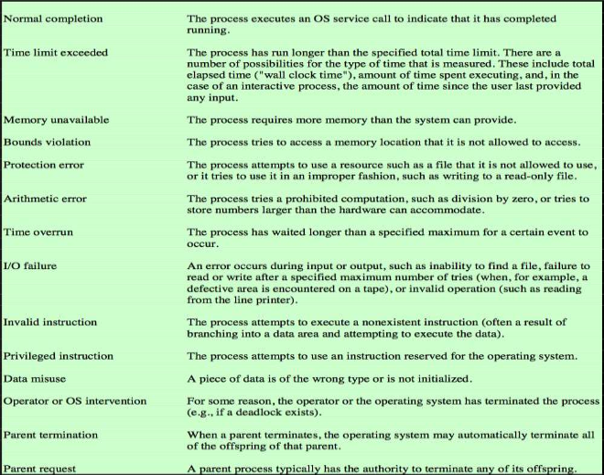

* + There must be a way for a process to indicate it’s completion (exit(), etc.)
    - A batch job should include a HALT instruction or an explicit OS call for termination
    - In an interactive application, the action of the user will indicate when the process is completed
      * e.g. log off, quitting an application, control-c, control-z
* **Process State**
  + **Two-State Process Model**

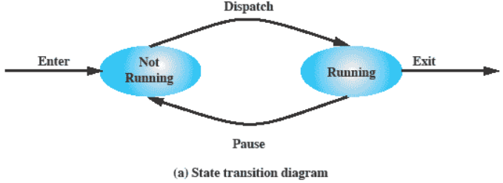

* + - A process may be in one of two states - running or not running

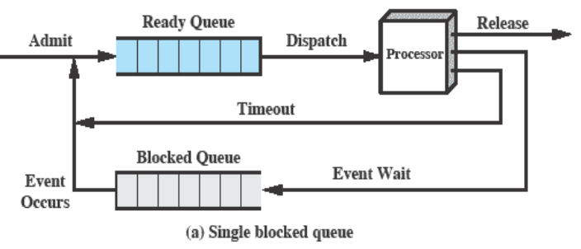

* + - **Multiple Blocked Queues**

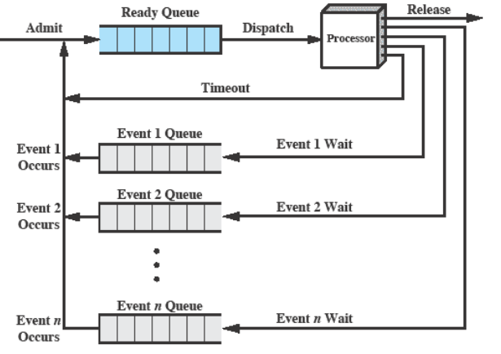

* + **Processes in a Queue**

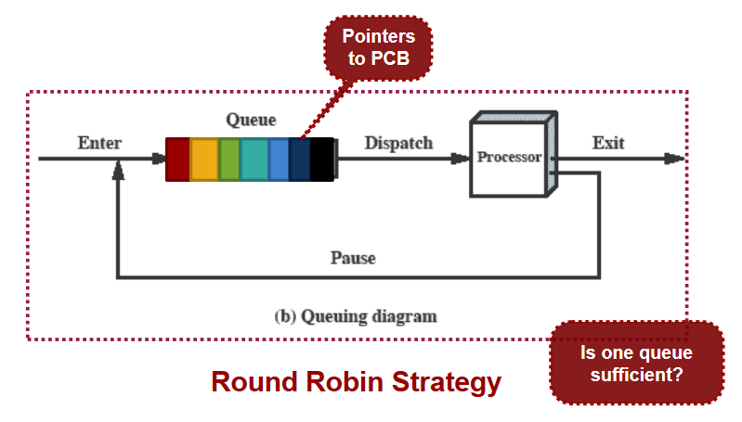

* + **Five-State Process Model**

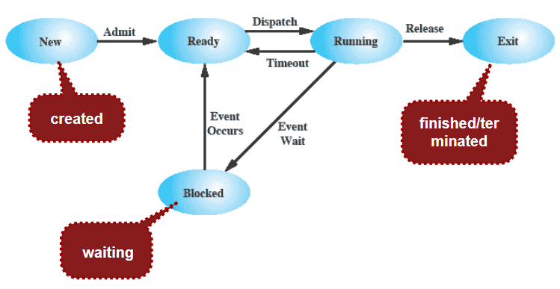

* **When will a process be suspended?**
  + **Suspended Processes**
    - **Swapping**
      * Moving parts of a process from main memory to disk
      * When none of the processes in main memory are in a READY state, OS swaps one of the BLOCKED Processes out onto disk into a SUSPEND queue
        + Then brings in another process from the suspend queue or honours a new process request

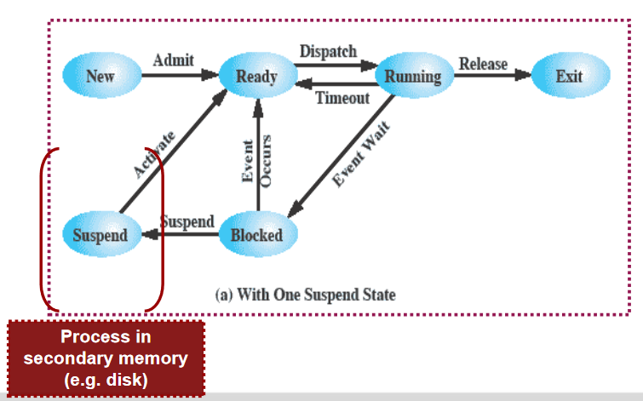

* + - **Two Suspend States**

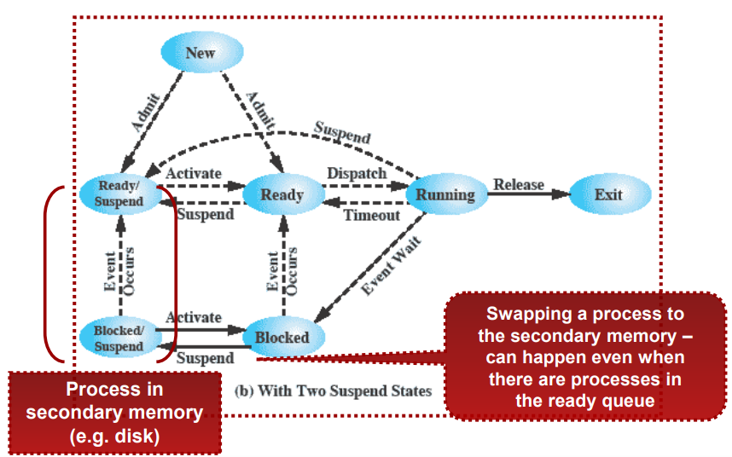

* + - * **Event Occurs** - when the event for which the process is waiting has occurred
      * **Activate** - when the event for which the process is waiting has occurred and the process can be moved into main memory
      * **Suspend** - low priority process or using some resources excessively, OS choses to suspend
    - **Characteristics**
      * The process is not immediately available for execution
      * The process was placed in a suspended state by an agent (either itself, a parent, or the OS) for the purpose of preventing its execution
      * The process may or may not be waiting on an event
      * The process may not be removed from the suspended state until the agent explicitly orders the removal
    - **Reasons**
      * **Swapping**
        + The OS needs to release sufficient main memory to bring in a process that is ready to execute
      * **Other OS Reason**
        + The OS may suspend a background or utility process or a process that is suspected of causing a problem (e.g. deadlock)
      * **Interactive User Request**
        + A user may wish to suspend execution of a program for the purposes of debugging, etc.
      * **Timing**
        + A process may be executed periodically (e.g. an accounting or system monitoring process) and may be suspended while waiting for the next time interval
      * **Parent Process Request**
        + A parent process may wish to suspend execution of a descendant to examine or modify the suspended process, or to coordinate the activity of various descendants
* **OS Control of Processes**
  + **Control Tables**

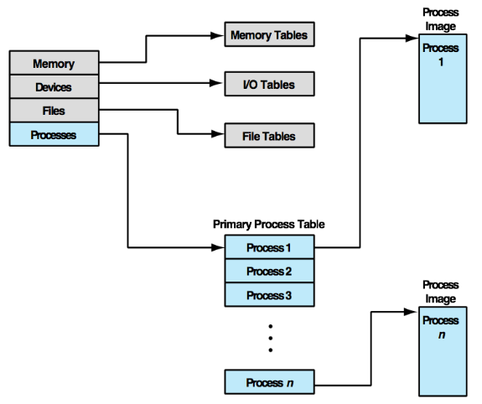

* + - **Process Tables**
      * Must be maintained to manage processes
      * Each entry contains (at least) one pointer to the process image
      * Must be some reference to other system resources (e.g. memory, I/O, and files - either directly or indirectly)
        + Keep track of each process’ memory, I/O operations

Essentially, what resources the process is using

* + - * Must be accessible by the OS - subject to memory management
    - **What does the OS need to know?**
      * **Where the process is located - main memory or elsewhere?**
        + A process must include a program or set of programs to be executed
        + A process will consist of (at least) sufficient memory to hold the programs and data of that process
        + Execution of a program typically involves a stack to keep track of procedure calls and parameter passing between procedures
      * **Which attributes of the process are necessary for its management** 
        + Each process has a number of attributes associated with it, which are used by the OS for process control

**aka PCB**

* + - * + Collection of program code, data, stack, and attributes is referred to as **process image**
        + Process image depends on the memory management scheme being used
    - **Process Image**
      * **Typical Elements:**
        + **User Data** - the modifiable part of user space (e.g. program data, user stack area, and programs that may be modified)
        + **User Program** - the program to be executed (machine code instructions)
        + **Stack** - each process has one or more LIFO stacks associated with it, used for storing parameters and calling addresses
        + **Program Control Block (PCB)** - data needed by the OS to control the process

**Identifier**

Numeric identifiers that may be stored include:

Process identifier (PID)

Parent Process Identifier (PPID)

User Identifier (UID)

Need to have an identifier so you can even find the process

**Processor State Information**

**User-Visible Registers**

A register that may be referenced by machine language - executed in user mode

Generally 8 to 32 of these registers

**Control and Structure Registers (aka Context)**

**PC** - Program counter

**Condition Code** - Results of the most recent arithmetic or logical operation (e.g. sign, zero, carry, equal, etc.)

**Status Information** - interrupt enable/disable flags, execution mode, etc.

**Stack Pointers**

One or more LIFO system stacks associated with the process for the purpose of storing parameters and calling addresses for system calls / procedures

SP points to top of stack

* + **Process Identification** 
    - * Each process is assigned a unique identifier (PID)
        + **Index** in the primary process table
        + **Mapping** for OS to locate the appropriate tables based on the process identifier
      * Many of the tables controlled by the OS may use process identifiers to cross-reference process tables
      * When processes communicate with one another, the process identifier informs the OS of the destination of a particular communication
      * When processes are allowed to create other processes, identifiers indicate the parent and descendants of each process
    - **Processor State Information**
      * Consists of the contents of processor registers:
        + User-visible registers
        + Control and status registers (e.g. PC, PSW)

**Program Status Word (PSW)**

*Used to set up the mode of a CPU when we context switch*

A register or set of registers

Contains condition codes plus other status information

Interrupt enabled, execution mode

Arithmetic overflow

* + - * + Stack pointers
      * **Process Control Information**
        + Additional information needed by the OS to control and coordinate various active processes

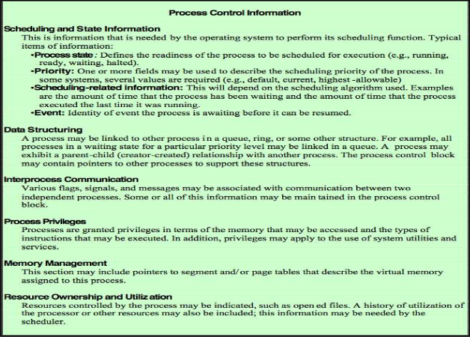

* + **Process Image Structure**

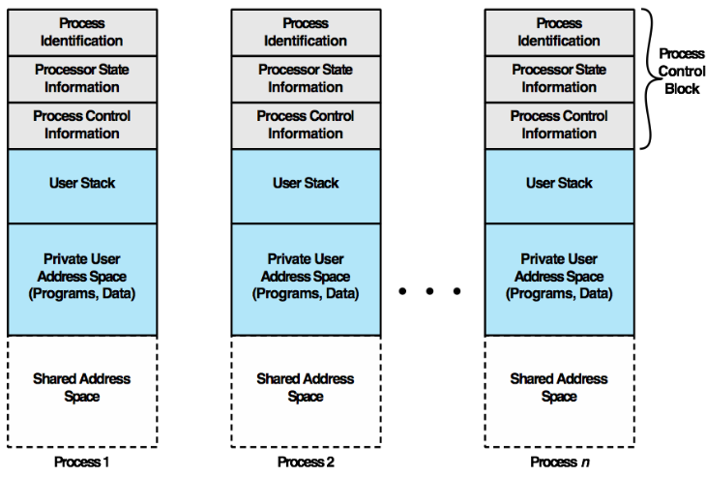

* + **Process List Structure**

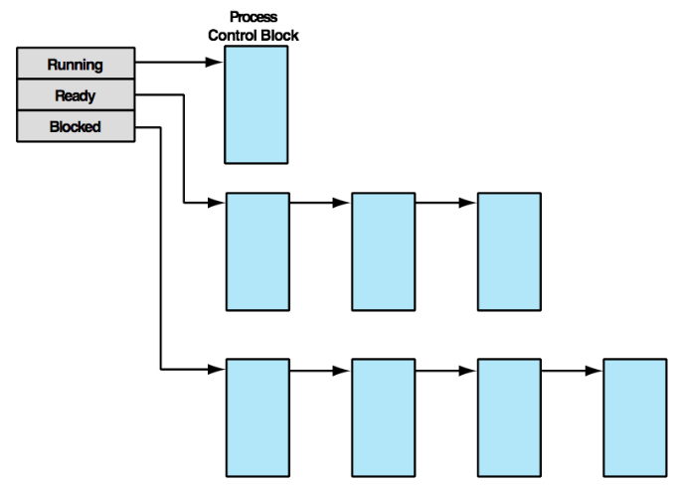

* **Role of Process Control Block (Recap)** 
  + Most important data structure in an OS
    - A set of PCBs define the state of the OS
  + Contains all of the information about a process that is needed by an OS
  + Blocks are read and / or modified by virtually every module in the OS
    - e.g. scheduling, resource allocation, interrupt processing, performance monitoring
* **Process Switching / Context Switching**
  + Process switch may occur any time that the OS has gained control from the currently running process
    - **Interrupt**
      * **Cause:** External to the execution of the current instruction
      * **Use:** Reaction to an asynchronous external event
        + e.g. when a process has used up its CPU time slice (e.g. CPU timer interrupt)
    - **Trap**
      * **Cause:** Associated with the execution of the current instruction
      * **Use:** Handling of an error or an exception condition
        + E.g. arithmetic overflow
    - **Supervisor Call**
      * **Cause:** Explicit request
      * **Use:** Call to an OS function
  + **Full Process Switch Steps**

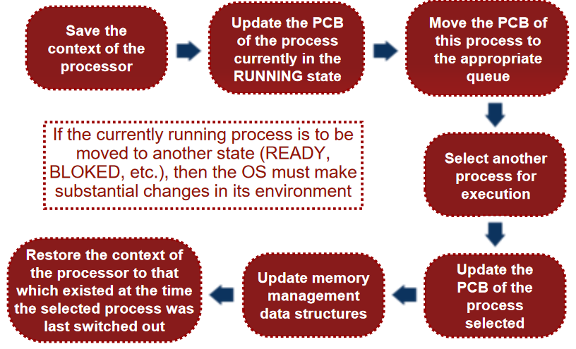

* **Tutorial - fork()**
  + Fork is the Linux system call used to spawn a child process. It runs twice (both in the child, returning 0, and the parent, returning the child PID)

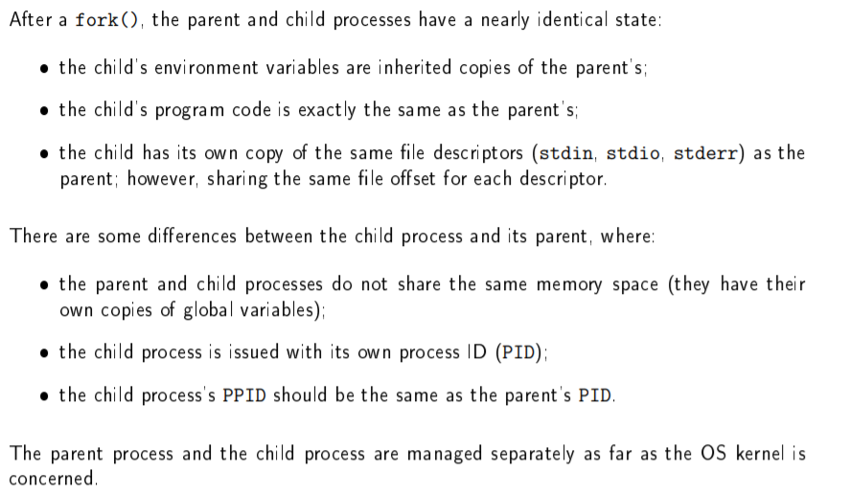

* A command line parser works by calling creating a fork which is then used to execute the requested program (assuming a fork can be made)

# Week 6 - Uniprocessor Scheduling

* **Processor Scheduling**
  + To assign processes to be executed by the processor in a way that meets response time, throughput, and processor efficiency
  + Broken down into three functions:
    - **Long-Term Scheduling** - the decision to add to the pool of processes to be executed
    - **Medium-Term Scheduling** - the decision to add to the number of processes that are partially or fully in memory
    - **Short-Term Scheduling** - the decision as to which available processes will be executed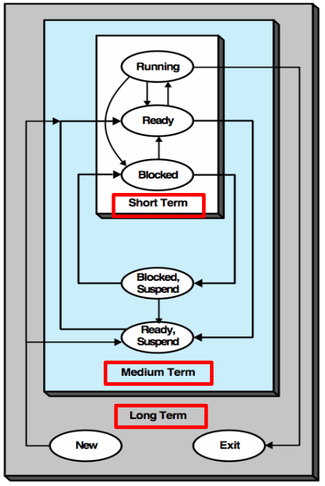

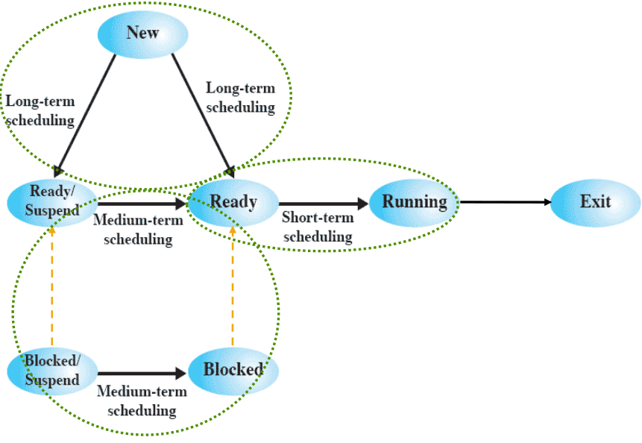

* **Scheduling Functions**
  + **Long-Term**
    - Controls the degree of multiprogramming
      * More processes that are created, smaller percentage of time that each can be executed
      * May limit to provide satisfactory service to the current set of processes

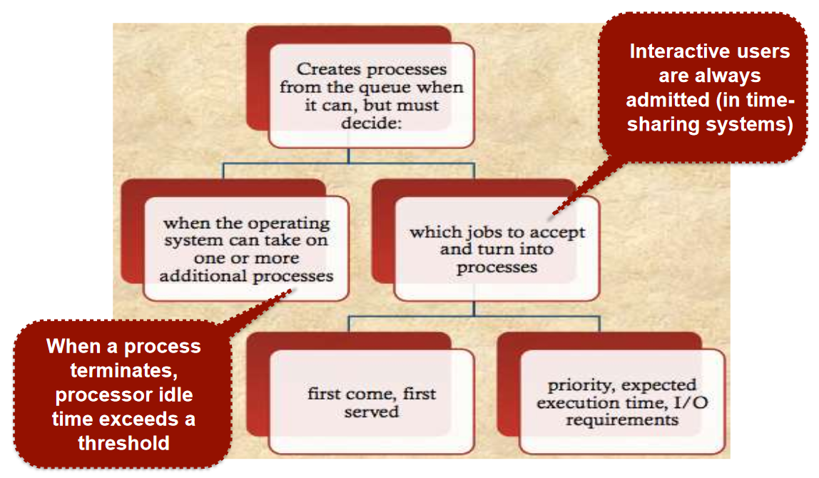

* + **Medium-Term**
    - Part of the swapping function
    - Swapping-in decisions are based on the need to manage the degree of multiprocessing - considers the memory requirements of the swapped-out process
      * Memory management can be a major issue here
  + **Short-Term**
    - Known as the **dispatcher** or **CPU scheduler**, it makes the fine-grained decision of what to execute next
      * Invoked whenever an **event** occurs (clock interrupts, system calls, signals, etc.)
        + May lead to blocking of the current process, but may also provide an opportunity to preempt a currently running process
    - **Scheduling Criteria**

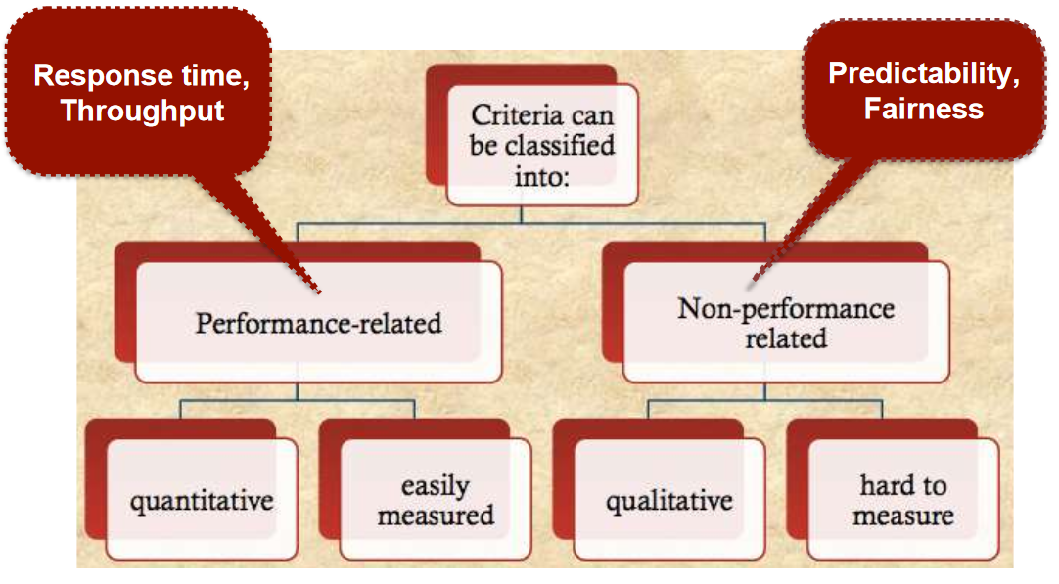

* + - * A set of criteria is needed to evaluate the scheduling policy; with the main objective of allocating processor time to optimise certain aspects of system behaviour
      * **User-Oriented**
        + Important on virtually all systems
        + System behaviour as perceived by user or process (e.g. response time)
      * **System-Oriented**
        + Minor importance on single-user systems
        + Effective and efficient utilisation of processor - the throughput (rate of completion of processes)
* **Scheduling Policies**
  + **Selection Function**
    - Determines which ready process is selected next for execution
    - Can be based on priority, resource requirements, or the execution characteristics of the process
      * **Execution Characteristics** are important qualities, like:
        + **W** - time spent in system so far, waiting
        + **E** - time spent in execution so far
        + **S** - total service time required by the process, including e
    - **Decision Mode**
      * Specifies the instants in time at which the selection function is exercised
      * Can be **pre-emptive** or **non-preemptive**
        + **Pre-Emptive**

Currently running process may be interrupted and moved to Ready state by OS

**Preemption** occurs when new processes arrive, on an interrupt, or periodically due to time-out

* + - * + **Non-Preemptive**

Once running, a process will continue until the process terminates or blocks itself for I/O or OS services

* + **FCFS (First Come First Served)**
    - Simple approach - known as First-In-First-Out in a queuing system
    - When the current process ceases to execute, the longest waiting process in the Ready queue is selected
    - Performs much better for long processes than short ones (non-preemptive)
    - Tenders to favour processor-bound processes over I/O-bound processes

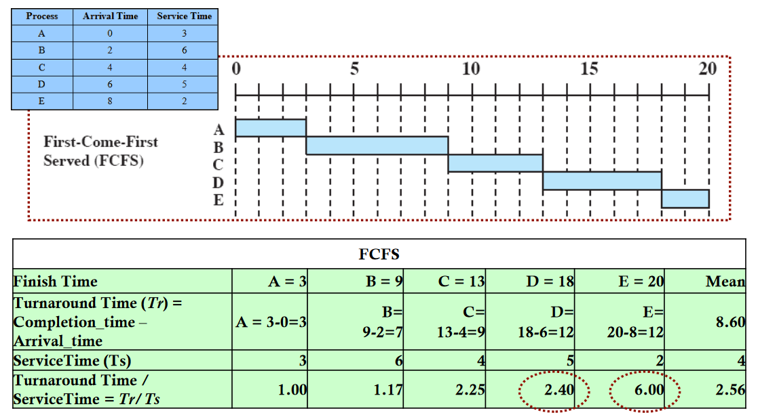

* + **RR (Round Robin)**
    - Uses preemption based on a clock (also known as time splicing)
      * Each process is given a certain amount of time before being preempted
      * Is the length of the time quantum, or slice, to be used?
        + Quantum should be slightly greater than the time required for a typical interaction or process function
    - Particularly effective in a general purpose time sharing system or transaction processing system

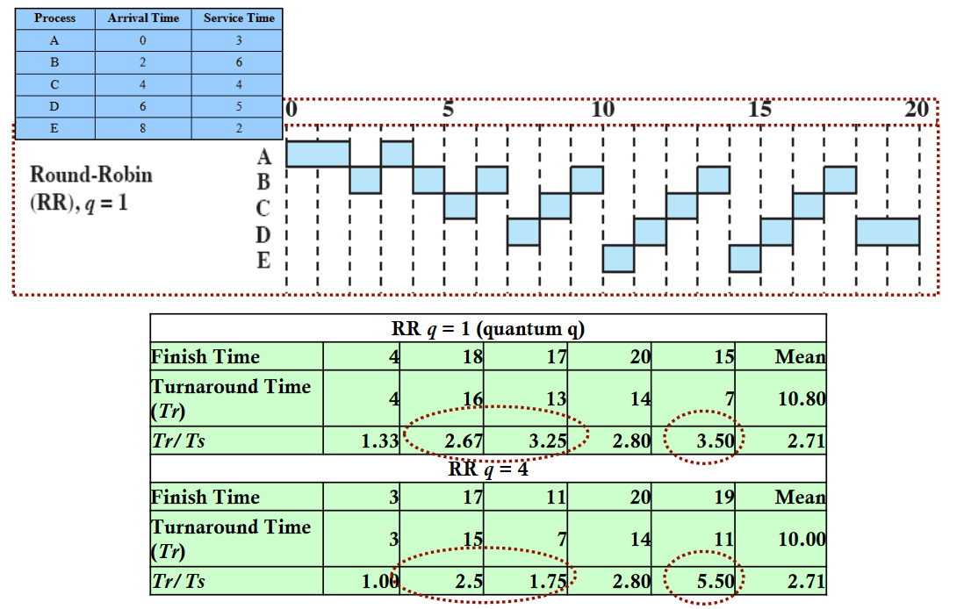

* + **SPN (Shortest Process Next) / SJF (Shortest Job First)**
    - Non-preemptive policy whereby the process with the shortest expected processing time is selected next
      * Inherent possibility of starvation for long processes
      * Need to know, or at least estimate, how long the required processing time of each process is
        + System may abort the job if the estimate is under the actual running time

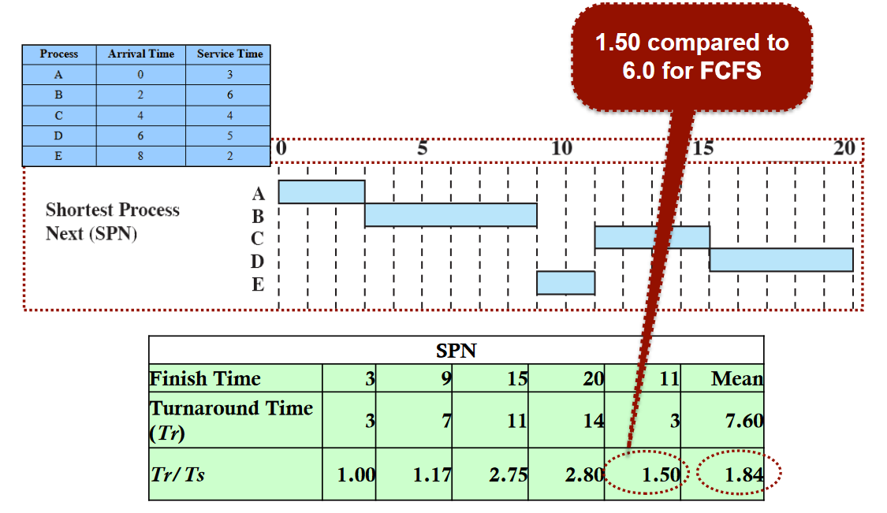

* + **SRT (Shortest Remaining Time)**
    - **Preemptive version of SPN** whereby the scheduler always chooses the process that has the shortest expected remaining processing time
    - Should in theory given superior turnaround time to SPN as a short job is given immediate preference to a running longer job

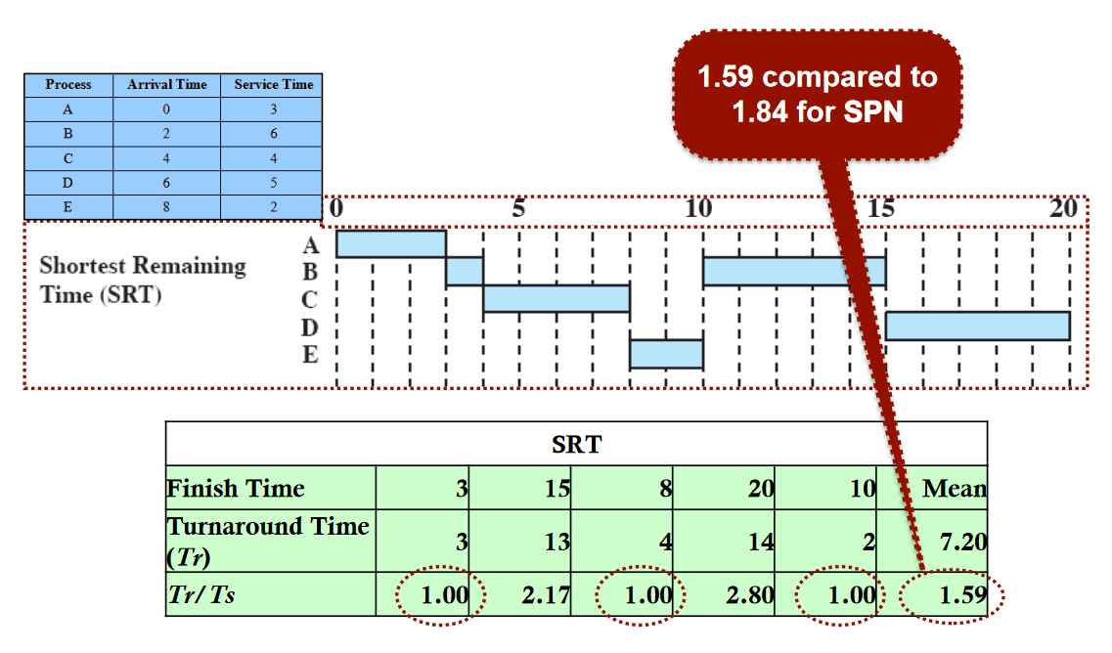

* + **Feedback Scheduling**
    - Scheduling is done on a preemptive basis, with a dynamic priority mechanism
      * When a process enters, it will enter into a FCFS queue and then run on the CPU.
      * When preemption occurs, it will drop down to a lower priority queue, and so on and so forth
        + There are generally only 3 or 4 of these queues
    - *Focuses on the time spend on CPU rather than predicting how much CPU time a process will use*
      * We can use the position of the process in these queues to determine how long a process has been running for
        + Instead of Shortest Remaining TIme, it’s how long has the process already been running

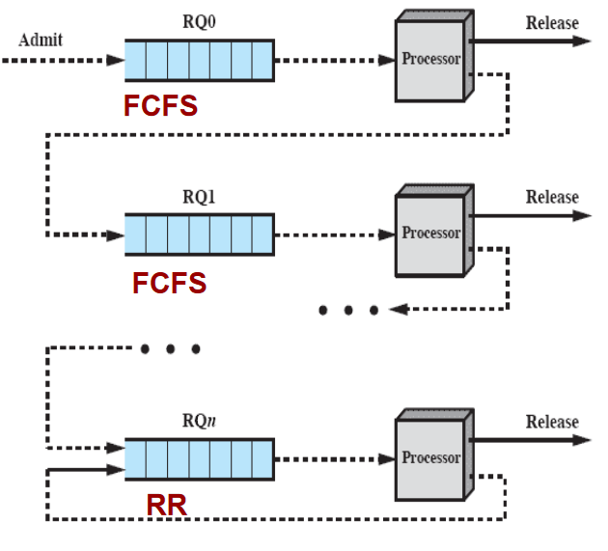

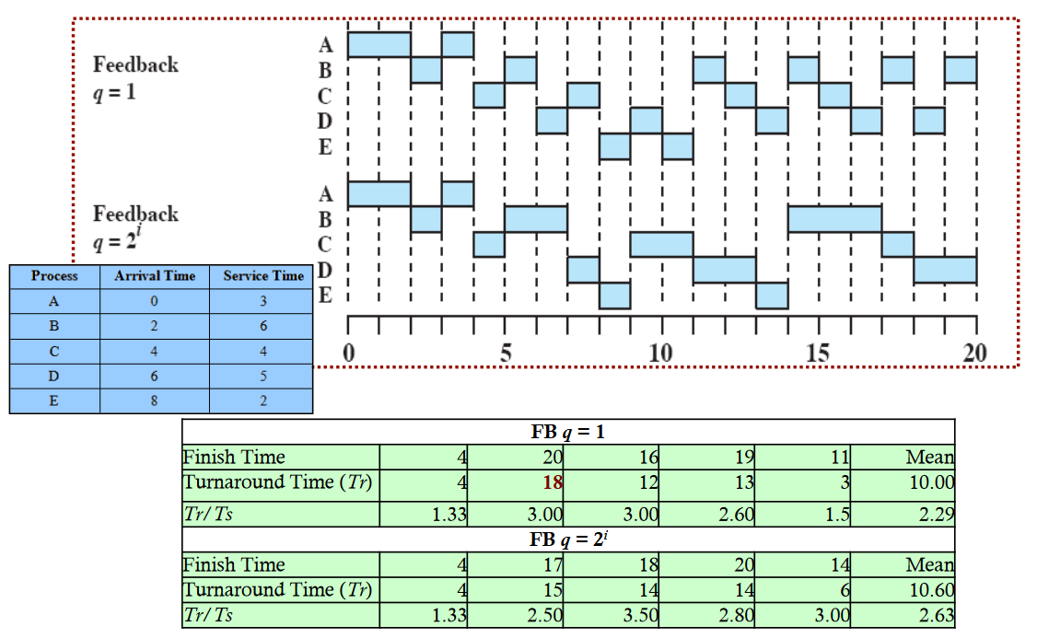

* + - RQ0 = 1 unit of time, RQ1 = 2 units of time, RQi = 2i units of time
      * When a long term process does run, it gets a longer time slice
        + Queue 0 = 1 time
        + Queue 1 = 2 time
    - Turnaround time for long processes will increase
      * However won’t get interrupted as frequently as time slice is longer
  + **Fair Share Scheduling (FSS)**
    - **Objective:** monitor usage to give fewer resources to users who have had more than their share, and more resources to those who have had less than their share
      * “Share” based on execution history and priority basis
    - Scheduling decisions are based on process sets
    - Each user is assigned a share of the processor

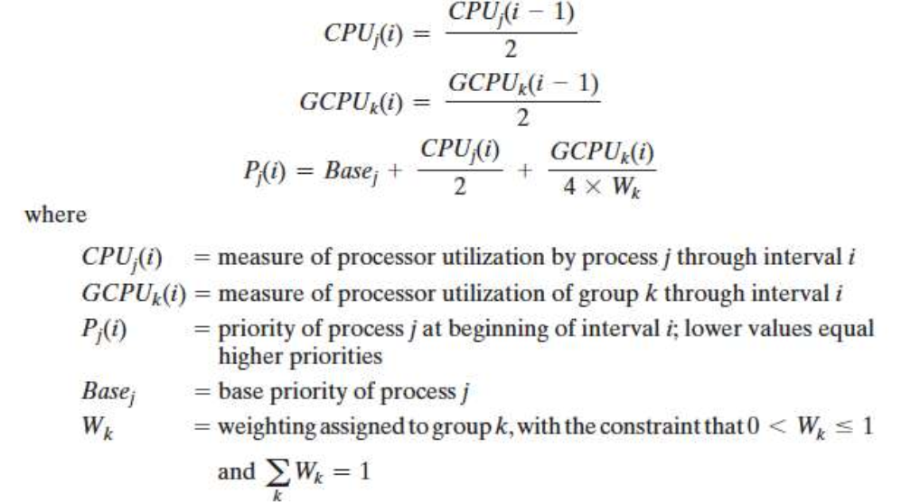

**NOT NECESSARY TO REMEMBER THIS MATHS FOR EXAM / MIDSEM**

* **Scheduling Characteristics**

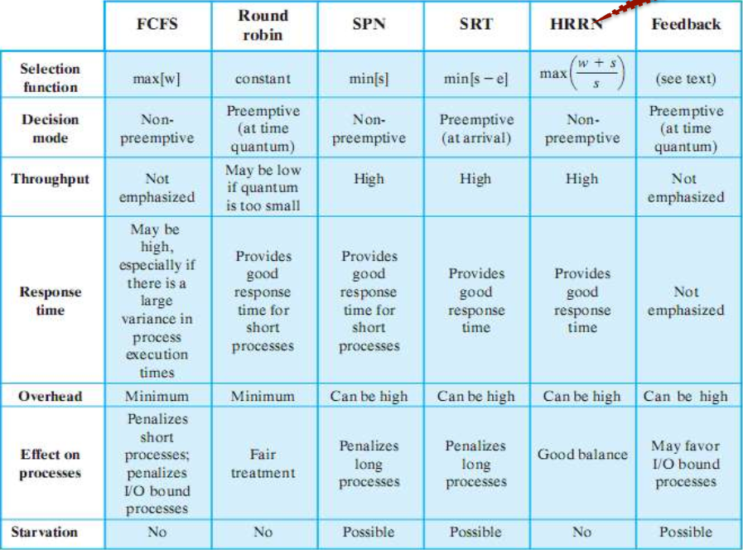

* **Traditional Unix Scheduling**

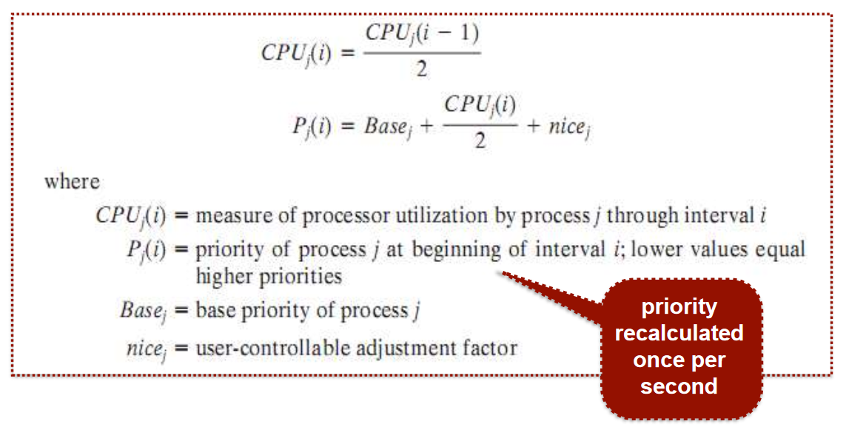

**NOT NECESSARY TO REMEMBER THIS MATHS FOR EXAM / MIDSEM**

* + Primarily targeted at the time-sharing interactive environment, and designed to give good response times for interactive users while ensuring that low-level background jobs do not starve
  + Employs multi-level feedback using round robin within each of the priority queues
    - Priority is based on process type and execution history
    - Round-Robin employs a one-second preemption
  + **Process Bands**
    - Used to optimise access to block devices, and allow the OS to respond quickly to OS calls
    - In decreasing order of priority:
      * **Swapper**
      * **Block I/O Device Control**
      * **File Manipulation**
      * **Character I/O Device Control**
      * **User Processes**

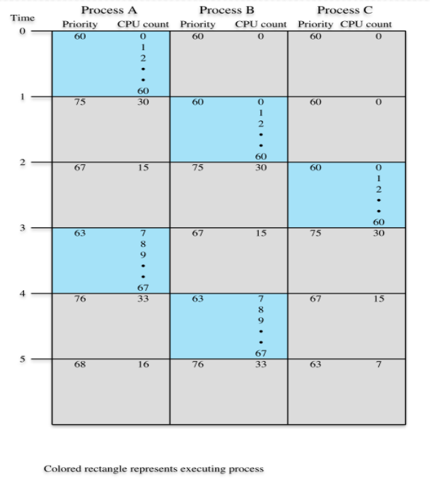

# 

# Week 7 - Mid-Semester Test

* No new content!

# Week 8 - Threads and Concurrency Part 1

## 8A Threads

* + **What is a *thread* to a *process*?**

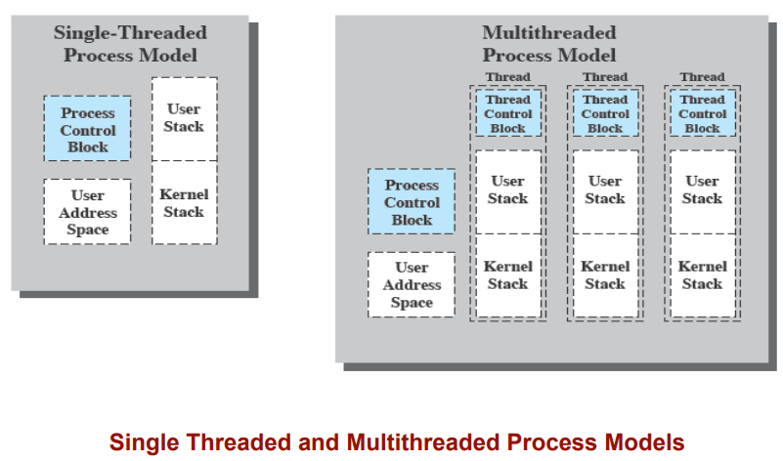

* + - A unit of dispatching for execution is referred to as a thread or as a lightweight process.
    - The unit of resource ownership is referred to as a process (the entity that owns a resource is a process) or a task (e.g. Windows or Unix)
    - **Multithreading** - the ability for the OS to support multiple concurrent paths of execution within a single process
      * 1 process = multiple threads of execution

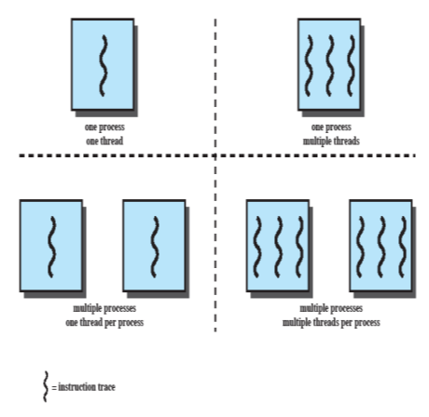

* + - **Left side of image =** single thread approach, a single thread of execution per process. Common in DoS, etc.
    - **Right side of image** = multithreaded approach, one process with multiple threads. Common in Windows and Linux
  + **Threads within a process**
    - Different parts of a program may do different things, which can be executed concurrently to improve response or completion time
      * e.g. one thread renders an image (processor bound), while another responds to user interaction
    - If there is an interaction between different parts of the program, concurrency control must be applied
      * e.g. modifying a common variable - mutual exclusion must be satisfied

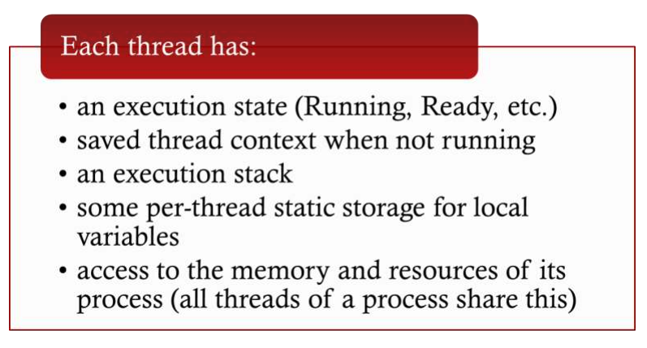

* + **Benefits of Threads**

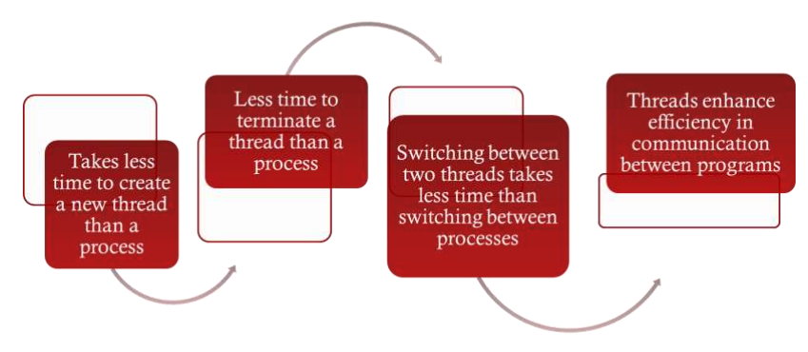

* + - They are lightweight processes, and thus can be handled as such

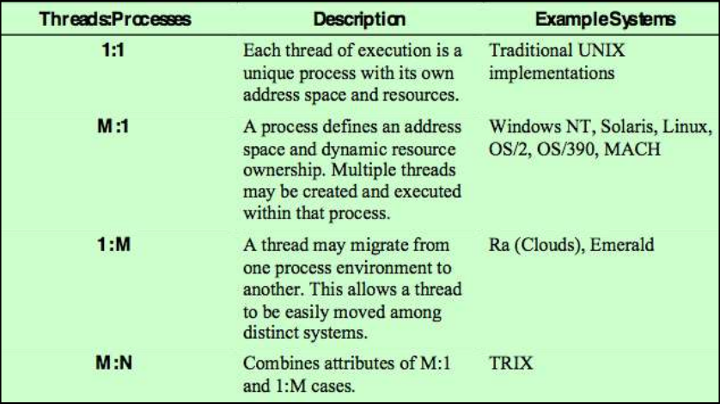

* + **More Thread Specifics**
    - For an OS that supports threads, scheduling and dispatching is done on a thread basis
    - Most of the state information dealing with execution is maintained in thread-level data structures
      * Suspending a process means suspending all threads of a process
      * Termination of a process terminates all threads of a process
    - All threads share the same address space
  + **Thread States**

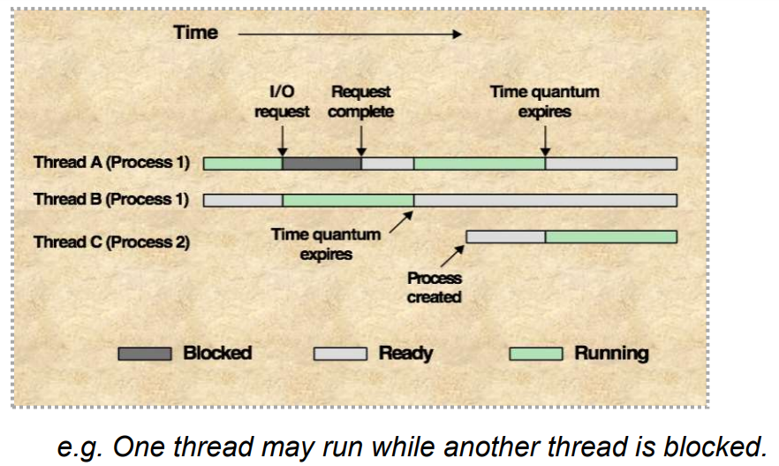

* + - RUNNING, READY, BLOCKED
    - **Thread State Transitions**
      * Spawn
        + New threads
      * Block
        + Wait for an event
      * Unblock
        + Move the thread to the ready queue
      * Finish
  + **Thread Synchronisation**
    - It is necessary to synchronise the activities of threads - **any** alteration of a resource by one thread affects the other threads in the same process
      * All threads of a process share the same address space (e.g. global variables) and other system resources
  + **User-Level Threads (ULTs)**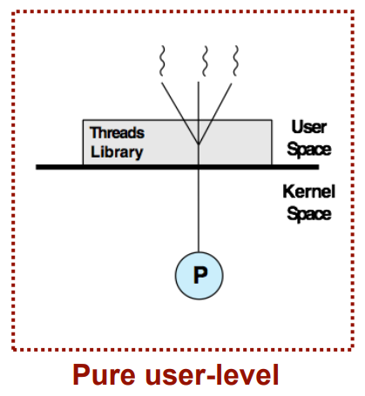
    - All thread management is done by the application, and the kernel is not aware of the existence of any threads
    - Any application can be programmed to use threads by using a thread library, **even if the OS does not support threads**
    - **Advantages?**
      * Thread switching doesn’t required kernel mode privileges
      * Scheduling can be application-specific
      * ULTs can run on any OS
    - **Disadvantages?**
      * When a ULT executes a system call, not only does that thread get blocked, but the whole process (and therefore any other threads)
        + In a pure ULT strategy, a multithreaded application cannot make full use of multiprocessing

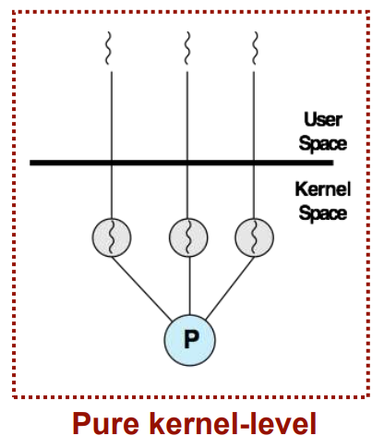

* + **Kernel-Level Threads (KLTs)** 
    - **ALL** thread management is done by the kernel - applications make use of an API through to the kernel thread facility
    - **Advantages?**
      * The kernel can simultaneously schedule multiple threads from the same process on multiple processors
      * If one thread in a process is blocked, the kernel can schedule another thread of the same process
      * The kernel routines can also be multi-threaded
    - **Disadvantages?**
      * The transfer of control from one thread to another thread within the same process requires a mode switch to the kernel (overhead)
  + **Combined Approach (KLT and ULT)**
    - Thread creation is done in userspace, with the bulk of scheduling and synchronisation of threads being done by the application
    - Multiple ULTs from a single application are mapped onto smaller (or equal number) of KLTs
  + **Unix Threads**
    - **Linux Tasks**
      * A process (or task) is represented by a task_struct data structure, consisting of:
        + Execution stage
        + Scheduling information
        + IDs
        + Links to parents / children / siblings
        + Timers
        + File system
        + Address space
        + Processor-specific contextual information
    - **PThreads**
      * Threads in Linux are called pthreads, and are managed through a separate API
      * The pthread library must be included and linked into the program in order to use threads
        + #include <pthread.h>
        + -lpthread argument in gcc (link to pthread)
        + pthread_create() - create a new thread
        + pthread_join() - wait for another thread to terminate
    - **Process / Thread Model**

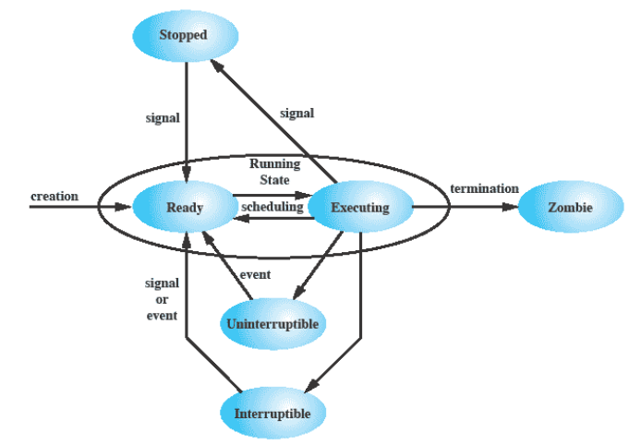

* + **Linux Namespaces**
    - A namespace enables a process to have a different view of the system than other processes that have other associated namespaces
      * Six namespaces in Linux
        + mnt
        + pid
        + net
        + ipc
        + uts
        + user
    - One of the overall goals to support the implementation of control groups / cgroups
    - A tool for lightweight virtualisation - provide a process or group of processes with the illusion they are the only processes on the system

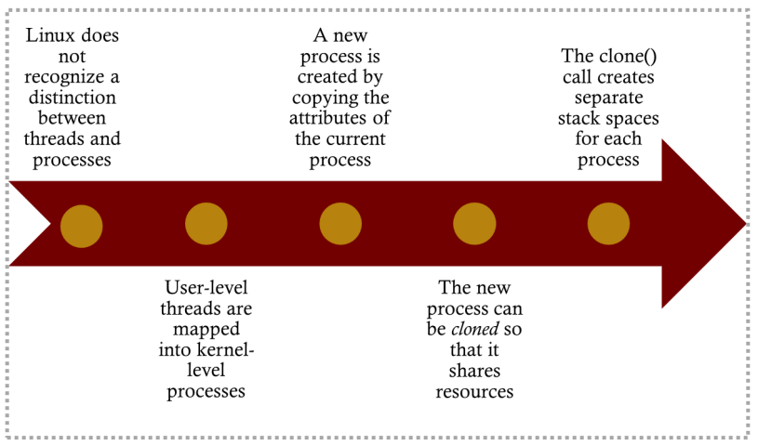

## 8B Concurrency Part 1

* + **OS Concerns**

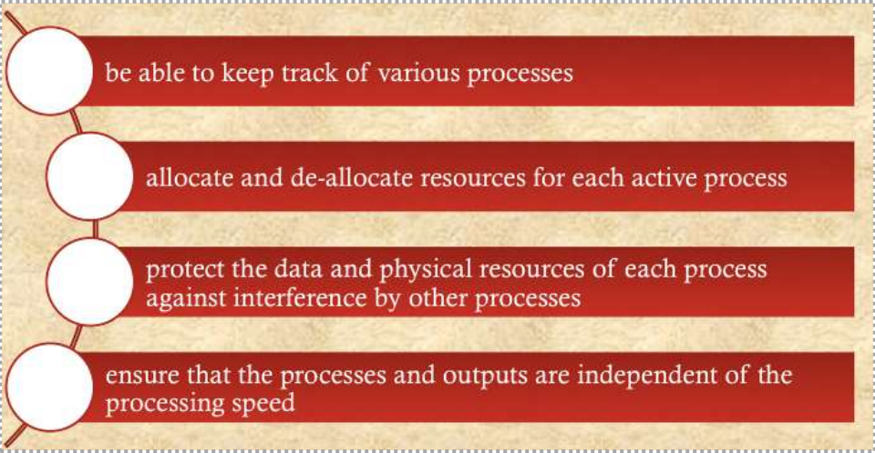

* + **Multiple Processes**
    - OS design is concerned with the management of threads and processes
      * **Multiprogramming** - many processes on uniprocessor system
      * **Multiprocessing** - many processes on a multiprocessor system
      * **Distributed Processing** - on a distributed computer system, such as a compiling cluster
  + **Concurrency** 
    - **Contexts**
      * **Multiple Applications** - allow processing time to be shared among active applications
      * **Structured Applications** - extension of modular design and structured programming
      * **Operating System Structure** - OS itself implemented as a set of processes or threads
    - **Terminology**
      * **Atomic Operation** - function or action implemented as a sequence of one or more instructions that appears to be individual.
        + The sequence of instructions is guaranteed to execute as a group, or not executed at all
        + Atomicity guarantees isolation from concurrent processes
      * **Critical Selection** - section of code within a process that requires access to shared resources and that must not be executed while another process is in a corresponding section of code
      * **Deadlock** - two or more processes are unable to proceed because each is waiting for one of the others to do something
      * **Livelock** - two or more processes continuously change their states in response to another process(es) change without doing any useful work
      * **Mutual Exclusion** - when one process is in the critical section that access shared resources, no other process many be in a critical section that accesses any of these resources
      * **Race Condition** - situation in which multiple threads or processes read and write a shared data item and the final result depends on the relative timing of their execution
      * **Starvation** - situation in which a runnable process is overlooked indefinitely by the scheduler
    - **Principles**
      * **Uniprocessor** - relative speed of execution of processes cannot be predicted
        + Depends on:

The activities of other processes

The way OS handles interrupts

The scheduling policies of the OS

* + - * **Multiprocessor** - interleaving and overlapping
        + Can be viewed as examples of concurrent processing, with both presenting the same problem as uniprocessor
    - **Difficulties**
      * Sharing of global resources
      * Difficulty of OS allocation of resources to be optimal
      * Difficulty of locating programming errors - results are non-deterministic by nature (and often not reproducible)
    - **Concurrency Problems**
      * Concurrent access to shared data may result in data inconsistency - “race condition”
        + Maintaining data consistency requires mechanisms to ensure the orderly execution of processes
        + **Race Conditions** occur when multiple processes or threads read and write data concurrently - meaning that the final result depends on the order of execution

Prevention - synchronisation of concurrent processes

* + - * **Uniprocessor Multiprogramming Example**

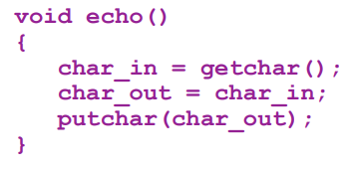

* + - * + P1 invokes echo, and gets interrupted after storing input into char_in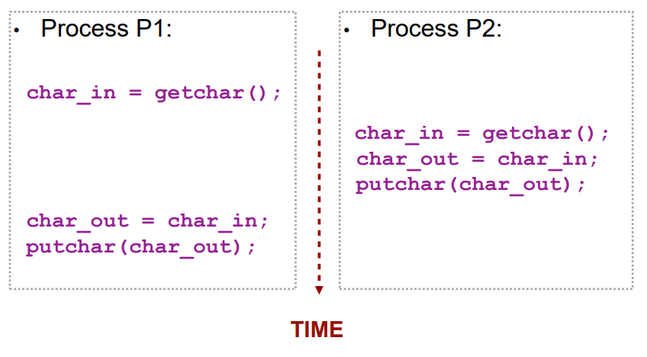
        + P2 invokes echo() and reads a char and runs to completion of process
        + When P1 resumes, the original value in char_in has been overwritten by P2
        + **Solution?**

Place a block on the echo() procedure while P1 is blocked

* + - * **Multiprocessor Multiprogramming?**
        + Same issue outlined above can occur, and can be resolved with the same block solution
        + Protecting and controlling access to shared resources is therefore critical on both uniprocessor and multiprocessor systems
  + **Process Interaction**

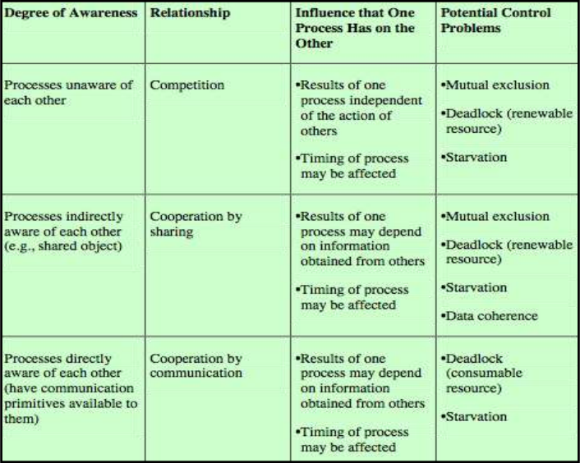

* + - **Control Problems**
      * Concurrent processes come into conflict when they are competing for the same system resource (e.g. processor time, devices, memory, etc.)
        + Three control problems - mutual exclusion, deadlock, starvation
      * **Mutual Exclusion**
        + Suppose n processes are all competing for the same shared resource - each process has a code segment (critical section), where the shared data is manipulated

We must ensure that when one process is executing in its critical section, no other process is allowed in its critical section

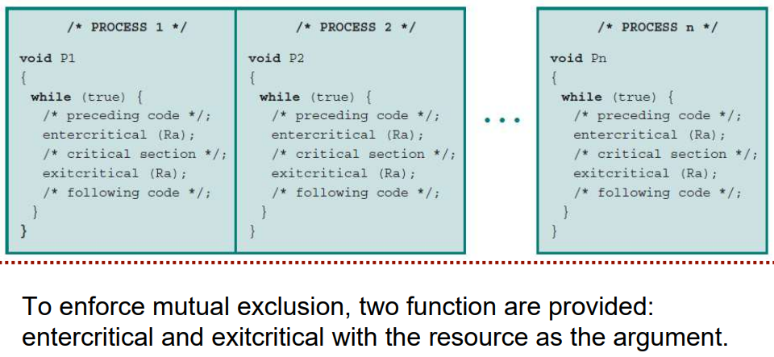

* + - * + **Multiple Shared Data Resources**

Issue exists even when processes access more than one shared resource

Processes must **cooperate** to ensure shared data is managed properly, and control mechanisms are needed to ensure **integrity**.

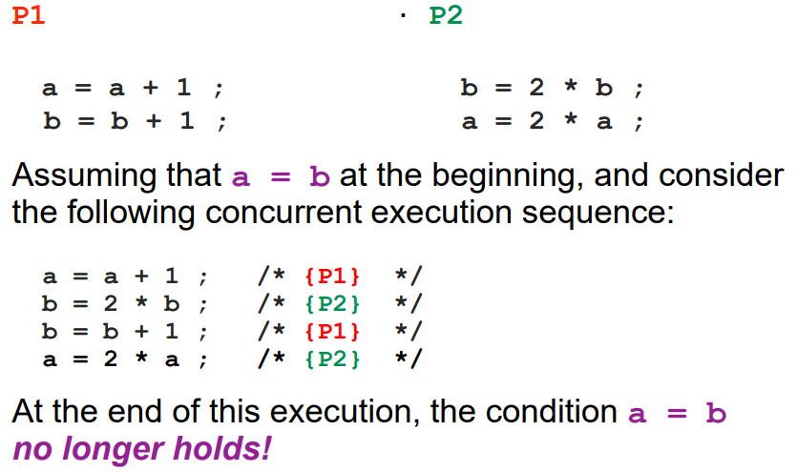

* + - * + **Mutual Exclusion Requirements**

Must be enforced

A process that halts must do so without interfering with other processes

A process must not be denied access to a critical section when there is no other process using the shared resource(s)

No assumptions are made above relative process speeds or number of processors, **but a process only remains in a critical section for a finite time**

* + - * **Deadlock** - two or more processes are waiting indefinitely for the other process to release the system resources
      * **Starvation** - indefinite blocking of a process

# Week 9 - Concurrency Part 2

* **The Problem of Concurrency**
  + **Concurrency** is the main concern in supporting multiple programming, multiprocessing, and distributed computing
    - **Race Conditions** - when multiple processes or threads read or write the same data items concurrently
    - **Mutual Exclusion** - condition whereby only one of many processes or threads are able to access a given resource or function at any item
  + **Control Mechanisms** 
    - To avoid race conditions, **critical sections** of code have to be serialised - i.e. make one thread wait for another
    - **Conditional Variables**
      * Make a process / thread wait until a condition is satisfied
      * When another process or thread completes the critical task, this condition is fulfilled (i.e. unblocking)
    - Semaphores
    - Mutexes
* **Semaphores**
  + **Concept of the Flag**
    - Set a FLAG when processing is using shared resource - others can check that flag and decide to enter or to wait in their critical section
      * Periodic checking for the availability of this flag is a wasted resource - so we generally signal to other waiting processes that we are done
    - BInary flag - on or off - as a form of semaphore
  + **Concept of the Semaphore** 
    - An integer variable is used for signalling among processes
      * Only three *atomic* processes are allowed on this integer - initialisation, increment, or decrement
    - Two types of semaphores:
      * **Binary** - takes on the value of 0 and 1
      * **Counting (General)** - takes integer values
    - **Semaphore Operation** 
      * May be initialised to a non-negative integer value
      * The semWait operation decrements the value
        + If the value becomes negative, then the process executing semWait is blocked
      * The semSignal operation increments the value
        + If the resulting output is greater than or equal to zero, then a process blocked by semWait is unblocked
    - **Consequences of a Semaphore** 
      * There is no way to know before a process decrements the semaphore if it will block or not
      * There is no way to know which process will continue immediately on a uniprocessor system when two processes are running concurrently
      * You do not know whether another process is waiting, so the number of unblocked processes may be zero one one

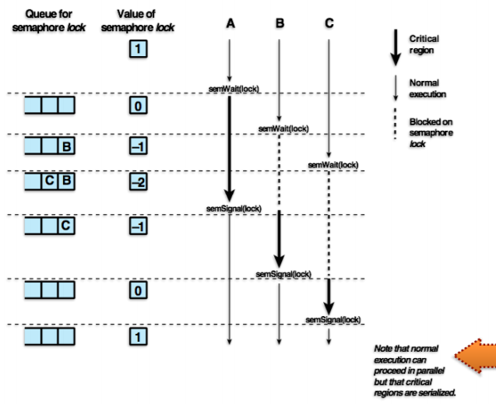

* **Mutex (Mutual Exclusion Lock)**
  + Mutex is a programming flag:
    - Set to 0 when it is locked
    - Set to 1 when it is unlocked
    - Only one process or thread can old the lock at any time
  + **Difference from binary semaphore?**
    - Only the process that locks the process or thread can unlock it
* **Deadlocks**

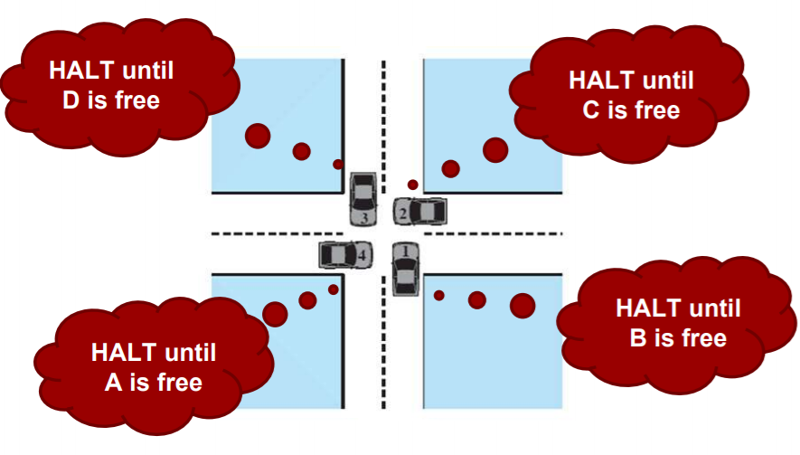

* + Permanent blocking of a set of processes that will either compete for system resources or communicate with each other
    - A set of processes is deadlocked when each process in the set is blocked awaiting an event that can only be triggered by another blocked process in the set
    - No single general efficient solution
  + **What resources do processes compete for?**
    - **Resource Categories**
      * **Reusable**
        + Can be safely used by only one process at a time and is **not depleted** by that particular use
        + Examples include processors, I/O channels, main and secondary memory, devices, and data structures such as files, databases, semaphores, etc.
        + **Two Processes Competing**

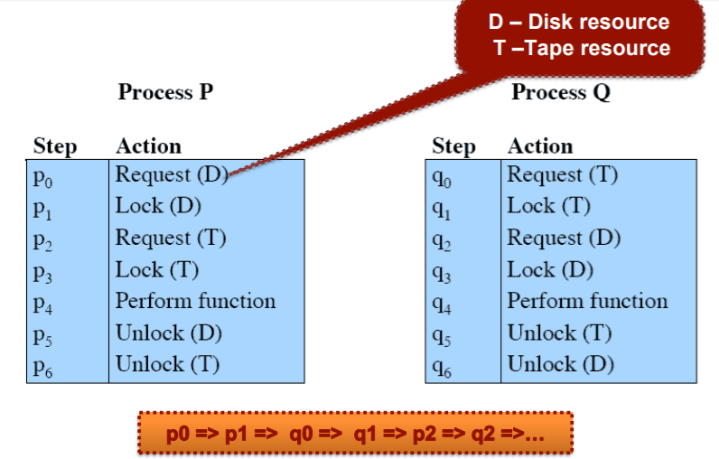

* + - * **Consumable**
        + One that can be created (produced) and destroyed (consumed)
        + Examples include signals, messages, and information in I/O buffers
        + **Two Processes Communicating**

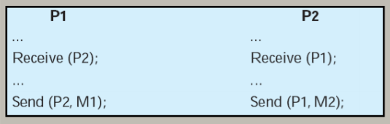

Consider a pair of processes, in which each attempts to receive a message from the other process and then send a reply

A deadlock occurs if the Receiver is blocked (i.e. the receiving process is blocked until the message is received)

* + - **Resource Allocation Graphs**

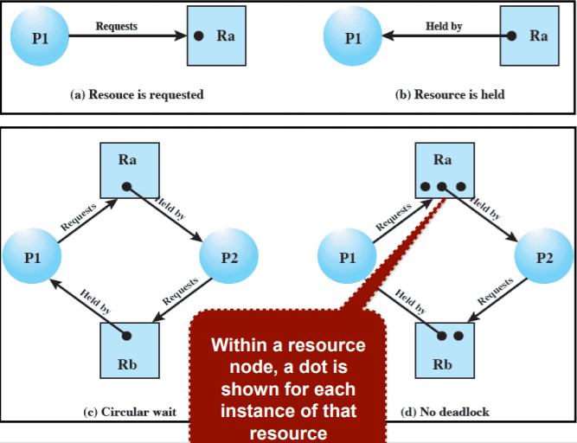

* + **Deadlock - Four Conditions**

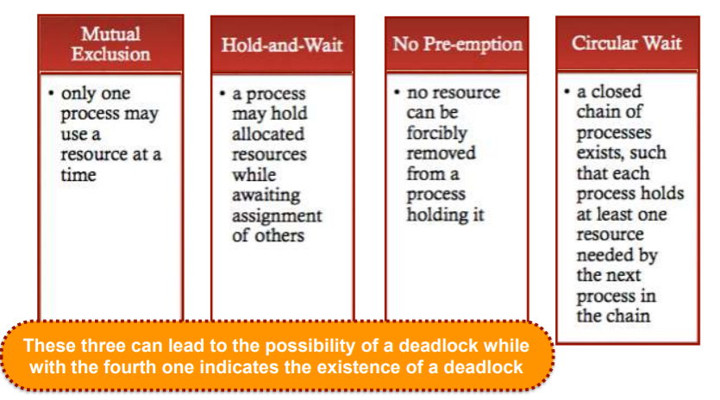

* + **Dealing with Deadlock**

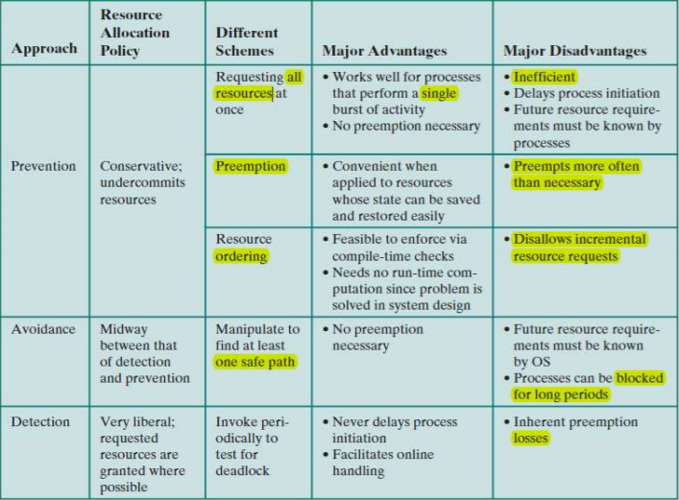

* + - **Prevention** - *adopt a policy that eliminates one of the conditions*
      * Design a system in such a way that deadlock is impossible
      * **Two Methods:**
        + **Indirect** - prevent the occurrence of one of the three necessary conditions
        + **Direct** - prevent the occurrence of a circular wait
      * **Condition Prevention**
        + **Mutual Exclusion**

If access to a resource requires mutual exclusion then it **must** be supported by the OS

Should not be disallowed

* + - * + **Hold and Wait**

Requires that a process request all of its required resources at one time and blocking the process can be done until all requests can be granted simultaneously

**Issue -** might not know all of the resources needed in advance

* + - * + **No Preemption**

If a process holding certain resources is denied a further request, then that request must release its original resources and request them again

An OS may preempt the second process (holding the requested resources) and require it to release its resources to the first process

**Issue -** only practical when states of resources can be saved and restored later

* + - * + **Circular Wait**

Define a linear ordering of resource types

Slow down processes and deny resource access

* + - **Avoidance** - *make the appropriate dynamic choices based on the current state of resource allocation*
      * Avoidance allows some level of concurrency, rather than prevention
      * **Inherent issue -** Requires knowledge of future process resource requests
      * **Approaches**
        + **Process Initiation Denial**

Do not start a process if its demands might lead to deadlock

* + - * + **Resource Allocation Denial**

aka “Banker’s Algorithm”

Do not grant an incremental resource request to a process if this allocation **might** lead to deadlock

State of the system reflects current allocation of resources to processes:

**Safe State**

There is at least one sequence of resource allocations to processes that does not result in deadlock

**Unsafe State**

A state not fitting the above criteria

**Determining a Safe State**

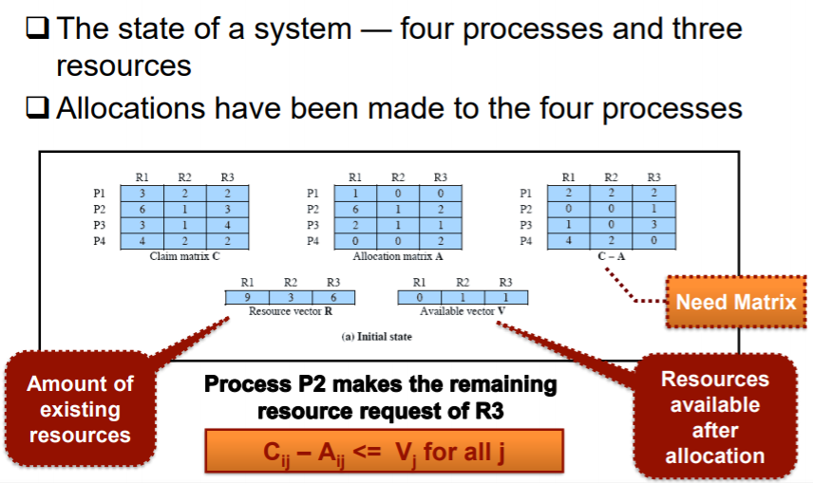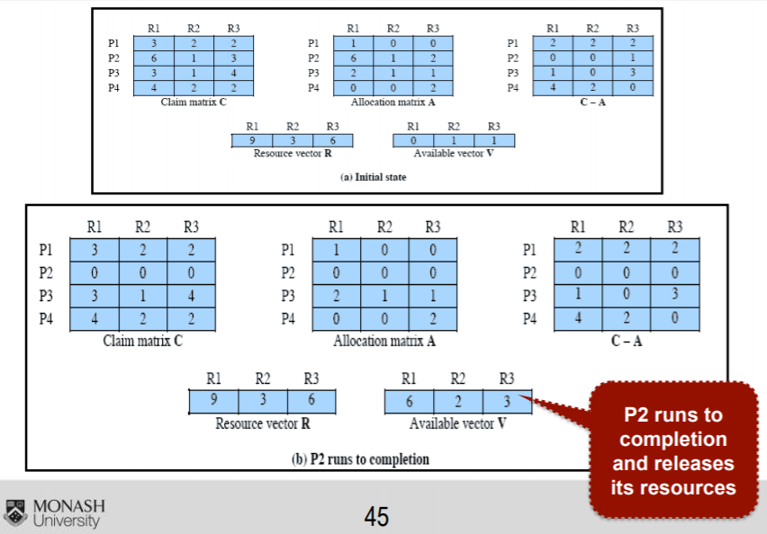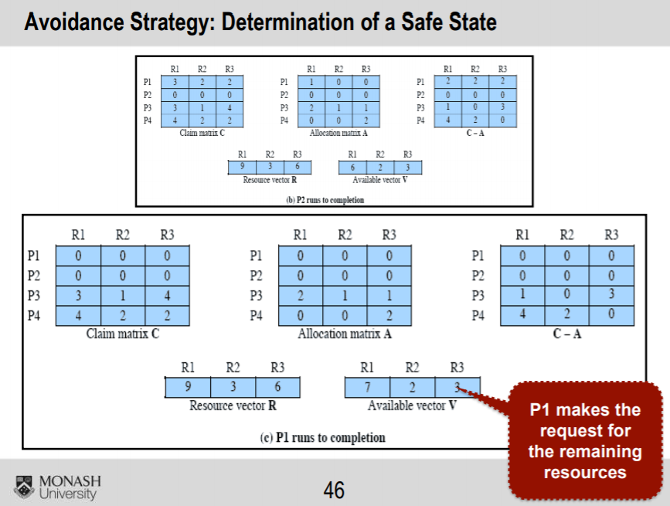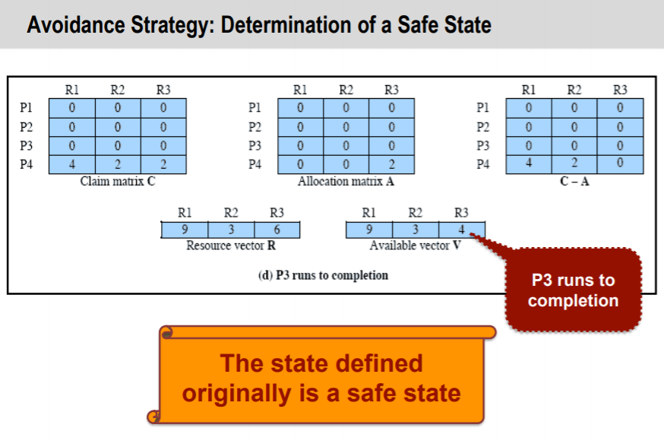

* + - * **Restrictions on Deadlock Avoidance**
        + Maximum resource requirements for each process must be stated in advance
        + Processes under consideration must be independent, and have no synchronization requests
        + There must be a fixed number of resources to allocate
        + No process may exit while holding resources
    - **Detection** - *attempt to detect the presence of deadlock and take actions to recover when needed*
      * **Prevention** strategies are conseravtive - they limit access to resources by imposing restrictions on processes
      * **Detection** strategies are the opposite - they grant resource requests wherever possible
      * **Detection Algorithms**
        + A check for deadlock can be made as frequently as each resource request, or less frequently depending on how likely it is for a deadlock to occur

Early detection with relatively simple algorithms, at the cost of high processor time

* + - * + **Process**

Mark each process that has a row in the allocation matrix of all zeros

Initialise temporary vector W to equal the Available vector

Find the index i such that process i is currently unmarked and the i-th row of Q (request) is less than or equal to W

That is, Qik<= Wk for 1 <= k <= m

If no such row is found, terminate

If such a row is found, mark process i and add to the corresponding row of the allocation matrix to W

That is, set Wk = Wk + Aik for 1 <= k <= m

Return to step 3

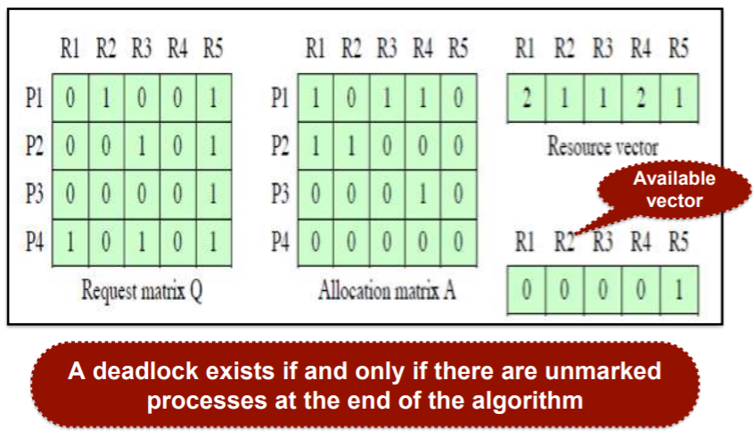

* + - * **Deadlock Recovery**
        + Abort all deadlocked processes
        + Back up each deadlocked process to some previously defined checkpoint and restart them all
        + Successively abort deadlocked processes until deadlock no longer exists
        + Successively preempt resources until deadlock no longer exists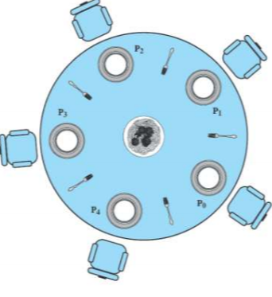
* **Dining Philosophers Problem**
  + Each philosopher needs 2 forks to eat
    - No two philosophers can use the same fork at the same time - **mutual exclusion**
    - No philosopher must starve to death - **deadlock avoidance and starvation**
  + **Solution 1 - Five Seated Philosophers**

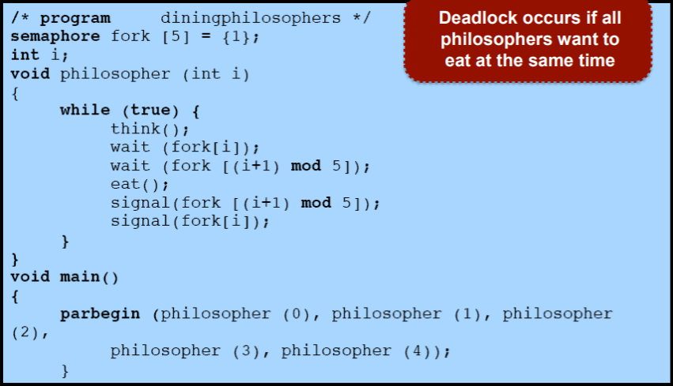

* + **Solution 2 - Four Seated Philosophers**

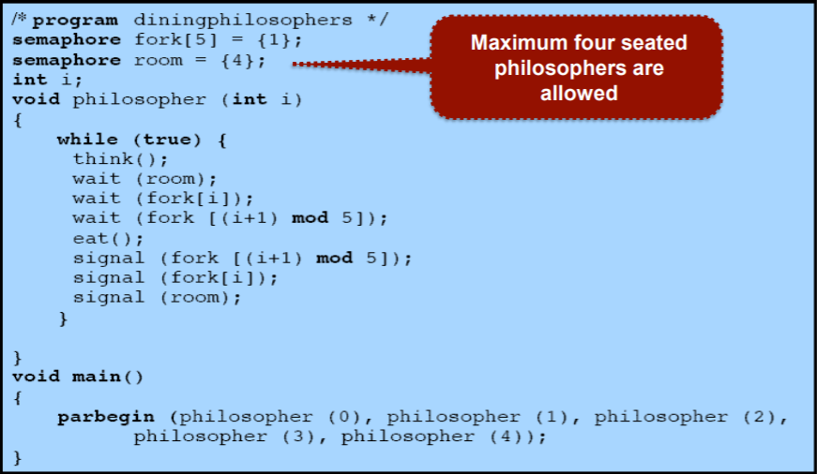

# Week 10 - Virtual Memory

* **Physical Memory**

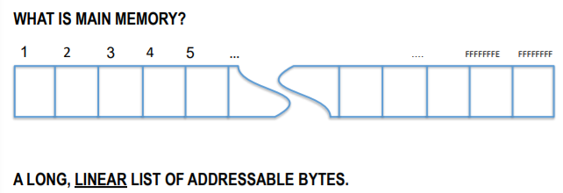

* **Virtual Memory - Abstraction of Physical Memory**
  + **Logical Addressing**
    - Instead of dealing with physical memory addresses directly, the OS gives programs **logical addresses** to work with
    - Logical addresses can be translated into physical addresses
    - **Real Memory Hiding** 
      * The logical address is also known as a virtual address, and it is used to hide the ‘real’ memory address from the program
      * All memory address pointers in C, C++, etc. are virtual addresses
  + **Why Virtualise the Address Space?**
    - **Efficiency**
      * Main memory is a limited, expensive resource - therefore we want to make better use of available memory
        + Buying more memory just results in most of it being unused
        + Swapping parts of the memory out to secondary storage when not required - paging or segmentation

Can allow for more processes to run at one time, and allow for a process that is larger than **all** of main memory to run

* + - **Security and Concurrency**
      * Enables protection against unauthorised access to another process’ memory space
      * Enables shared memory among related processes
        + e.g. when forking or running multiple instances of the same program, the code only needs to be loaded once

Therefore only need to see the logical copy of the program code, but the logical segments are translated into a common physical location (i.e. many to one mapping)

* + - **Flexibility (Relocation)**
      * If a program must be swapped out to secondary storage, then it’s original location in memory may not be available later on (e.g. not the same physical space)
      * Relocating a program means that all the physical memory addresses are different
        + Dealing with logical addresses means the program’s pointers remain valid, and therefore can continue running from anywhere
  + **Swapping**
    - Moving large chunks of data between main memory and secondary storage
      * Move unused process data to secondary memory, for example
    - **Is it useful?**
      * Allows for more complete utilisation of memory, but is **slow**
      * **Trashing -** the condition where time spent swapping data exceeds time spent executing instructions
    - **Two Approaches**
      * **Paging** - fixed size blocks of data
      * **Segmentation** - variable sized segments
* **Paged Virtual Memory** 
  + **Pages and Frames**
    - Physical memory is partitioned into equal sized **frames**.
      * All frames are of equal size, and can fit a single page (a chunk of data that is the same size as the frame)
    - Some pages might be in physical memory (loaded into frames), while others may be swapped out to secondary storage (taken out of frames)
    - OS kernel maintains a page table to keep track of which pages are in frames
  + **Fragmentation** 
    - **Internal Fragmentation**
      * A process may occupy one or more frames in memory - but if a portion of one frame is used, it cannot be used by another process
      * Since all pages are fixed size, any excess space is wasted
    - **External Fragmentation?** 
      * Doesn’t exist in a paged system - all pages are equally sized, so any empty frame in memory can always be allocated to a whole page
  + **Logical Addresses**
    - The memory address contains a page number and an offset

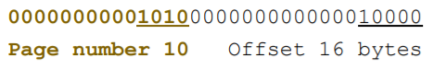

* + - The most significant bits in the logical address are used for the page number, and the remaining bits are an offset from the start of the page
      * Addresses are structured so the number of offset bits match the addressable range of the page size - therefore no out of bounds range
    - **Address Translation - Paging**

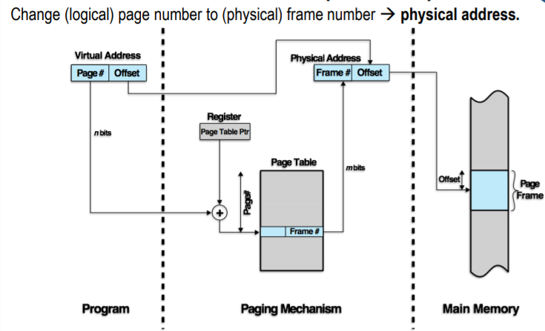

* + **Page Faults**
    - If a page does not have a frame in the page table, it means that the page does not have a physical address in memory - **page fault**
      * Therefore the requested logical memory address is valid, but the page is in secondary storage and must be loaded into a frame
    - **Bad?**
      * Not *necessarily*
      * If all frames are already full, then another must be swapped out to make room
        + We use a page replacement algorithm to determine which one should be swapped
  + **Page Replacement Algorithms**
    - Swap out a page that won’t be needed again for a long time (prevent thrashing) by making a fast guess, without being ‘too clever’
      * More accurate prediction → more computation time
      * Less accurate prediction → more page swaps needed
    - **First in First Out (FIFO)**

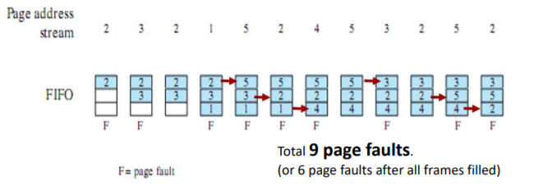

* + - * Page that has been in memory the longest is replaced
      * Treat frames allocated to processes as a queue for replacement
    - **Least Recently Used (LRU)**

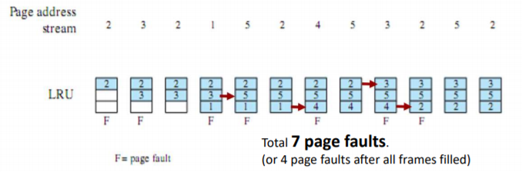

* + - * Replace the page that has not been referenced for the longest time
        + By principle of locality - pages that have been referenced recently are likely to be referenced again
        + High amount of overhead to maintain / check the last time since reference
    - **Optimal Policy (OPT)**

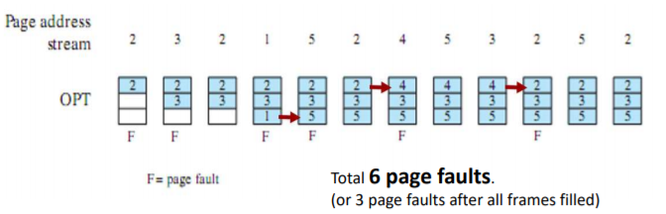

* + - * Replace the page that will not be referenced for the longest time
      * Impossible to implement in practice - the OS cannot see the future
    - **Summary**

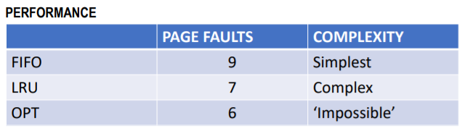

* + - * Page replacement algorithms are a tradeoff between minimizing page faults and minimising computational complexity
* **Segmented Virtual Memory**
  + **Segments**
    - A process is allocated one or more logical segments of memory
    - Segments vary in size up to a defined maximum size
    - There are no fixed frames in physical memory - segments are placed where space is available
      * Therefore may leave a hole when a segment is swapped out
  + **Segment Placement Algorithms** 
    - **Best Fit**
      * Chooses the block that is closest in size to the request
    - **First Fit**
      * Scan memory from beginning, and chooses the first available block that is large enough
    - **Next Fit**
      * Scan memory from the location of the last placement, and chooses the first available block that is large enough
  + **Fragmentation**
    - **Internal?**
      * A segment may grow or shrink based on required size - there is no concept of “wasted space”
    - **External**
      * A small segment may be swapped out, and the space left behind may be too small to fit another process
      * Compaction is the technique of periodically re-arranging segments to remove gaps (computationally intensive process)
  + **Logical Addresses**

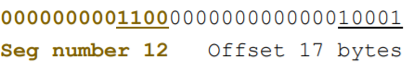

* + - The most significant bits ifn the logical address are used for the segment number, remaining bits are used for the offset from the start of the segment in physical memory
      * Segments can be different sizes, so if the offset goes past the end of a segment, the logical address is invalid - aka **segmentation fault**
    - **Address Translation**

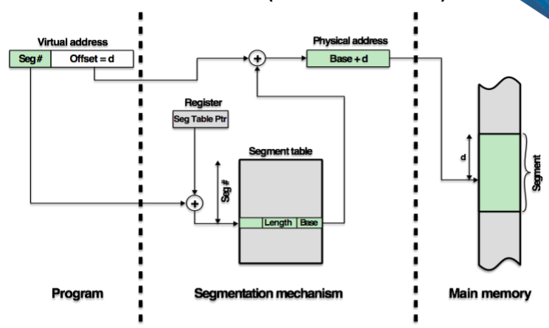

* + **Shared Memory** 
    - A segment in memory can be shared among processes
      * Like with multithreading, multiple processes can access each other’s memory
      * Unlike with multithreading, it does not happen automatically
        + Manually request a new block (with size specified) of shared memory be allocated
        + Manually assign a data structure to the shared block of bytes
    - No concurrency protection is provided, so mutual exclusion must be used
    - Shared memory is important for inter-process communication

# Week 11 - Interprocess Communication

* **IPC**
  + **What is IPC?** 
    - Communication between two or more processes
      * Multiple applications / utilities often need to communicate
      * Communication may happen over a network, but often communication happens among processes running on the same computer
  + **Why do we need IPC?** 
    - **Threads**
      * Memory is ‘shared’ between threads:
        + In actuality, there is only one memory space, with all threads being part of the same process
        + This is only communication within a process
    - **Processes**
      * Often, multiple processes need to exchange data
        + For example, stream output to a console utility with a print statement
      * Different processes do not typically share the same memory space
      * The OS provides a number of communication mechanisms
  + **Signals**
    - Most simple kind of IPC, used to inform a process of an asynchronous event
      * A signal has a signal number, which identifies the type of signal sent
        + Constant is defined in <signal.h>
      * A signal is delivered by updating a bit flag (field) in the process table for processes that receive this signal
    - No priorities for signals
    - A process may respond to a signal number by:
      * Jumping into a signal handler function
      * Ignoring the symbol
      * Performing the OS’ default action for that signal (e.g. terminate process)
      * **Dealing with Signals**
        + Unix system calls, defined in <signal.h>
        + **Handling a Signal**

The handler must be set up before the signal arrives

sighandler_t signal (int signal_number, sighandler_thandler)

The value of the xander may be a pointer to a handler function to be called, or SIG_IGN or SIG_DFL

* + - * + **Sending a Signal to Another Process**

Only need the PID and the signal type wished to be sent:

int kill (pid_tprocess, int signal_number)

* + - **Common Signals**
      * **SIGINT** - interrupt signal that is sent when you press Control + C in a terminal (Default action is to terminate the process)
      * **SIGSTP** - stop signal that is sent when you press Control + Z in a terminal (default action is to suspend / pause the process)
      * **SIGKILL** - kills a process without a way for the process to ignore the signal or handle it
  + **Shared Memory (SHM)**
    - IPC approach that works through the virtual memory system
    - **Shared Memory (Recap)**
      * Segment in memory may be shared among multiple processes
        + Like with multithreading, multiple processes can access each other’s memory
        + Unlike multithreading, it does not happen automatically
      * Using multiple processes with shared memory can be more robust than using threads
        + For example, if a process crashes, the parent process can restart it (e.g. tabs in web browsers)
    - **Using Shared Memory**
      * **System V Style**
        + Library functions in shm.h include shmget() and shmat()
        + Processes are required to have knowledge of a common key value in order to get access to the same segment
        + The key value is an integer that might be stored for other processes to look up, or simply generated prior to forking a child process
      * **POSIX Style (“Standard” Approach)**
        + Library functions in mman.h include shm_open() and mmap()
        + A filename in the filesystem is associated with a shared memory segment
        + When opened, the file descriptor can be read or written to, similar to a file
        + Can also be mapped to logical memory addresses using mmap()
      * **POSIX vs. System V?**
        + For either approach, there is no built-in concurrency protection - shared memory has the same hazards as multithreading
        + Mutual exclusion mechanisms such as semaphores or mutexes can be used when accessing shared data
  + **Stream-Based IPC - Unamed Pipes and FIFOs**
    - An approach to IPC that works through the kernel directly
    - **Pipes?**
      * *Bytes go in one end, come out the other end*
      * A buffer maintained within the kernel, where information is written at one end and outputs at the other end
        + Slower than SHM since all data must pass through the kernel itself
        + A pipe is like a file but with two file descriptors - one for writing and one for reading
      * A pipe enforces synchronisation between reader and writer by enforcing first-in-first-out behaviour
        + The reader cannot read past what has been written, and the writer cannot overwrite data until it has been written
        + Circular buffer is used for this effect
      * **Circular Buffer (Recap)**
        + The stream of bytes spans multiple buffers (character arrays)
        + At any one time, one buffer is selected for reading while another is being written to

Writer fills buffer while reader empties them, before moving onto the next buffer

If the reader catches up to the writer, further reads will be blocked until the next buffer is available.

If the writer catches up to the reader, further writes will be blocked until the next buffer is available.

* + - **Unnamed Pipes**
      * Can only be shared between related processes, created using pipe() system call
        + Creates a pipe and allocates two file descriptors
        + After a fork, the child will inherit the parent’s open file descriptors, meaning it can talk to the other process
    - **Named Pipes**
      * A kind of pipe with a filename in the filesystem, can be used between unrelated processes
      * A special ‘file’ created using the mkfifo() system call
      * One process then opens the ‘file’ as read-only, while another opens the same ‘file’ as write-only
  + **Sockets** 
    - One server process accepts connections from multiple client processes
    - **Example - Display Server Utility**
      * Only one process can control the display hardware at any given time - this is how Windows works
        + One utility called the **display server** takes responsibility for drawing all graphics to the screen
        + Applications (clients) connect to the display server and send instructions for what should be drawn (through an API)
        + The display server interprets instructions from different applications to produce a montage of windows on the screen
        + When the user interacts with the mouse and keyboard, the display server figures out which client to send the information back to.
    - **Sockets in Linux - “Unix Domain Sockets”** 
      * How is a socket created?
        + The server process creates a socket, which is mapped to a filename in the system
        + Client processes must connect to this file to reach the server
        + The server receives information about a new connection request, and chooses to accept the connection
        + When accepted, the OS provides an open file descriptor resource to both the client and server processes
      * Just like a pipe, a socket connection enforces FIFO behaviour
      * Unlike a pipe, a socket connection can send data in both directions
        + The kernel provides two circular buffers - one for bytes sent from the client to the server, and another for the opposite
  + **Message Queues** 
    - *A system for sending fixed-length messages between processes*
    - **What is a message queue?** 
      * A resource provided by the kernel used for more structured message passing
        + Once a queue has been created, multiple processes can send messages into the queue, or read them out of the queue
    - By defining a set of different message types (assigning an integer to different kinds of messages), a process can request the type of message it is waiting to be delivered next
      * Unlike streams (pipes, etc.) a message queue always servers a whole message at a time
    - **Message Format**
      * Messages are sent as fixed-length chunks, and consist of two parts:

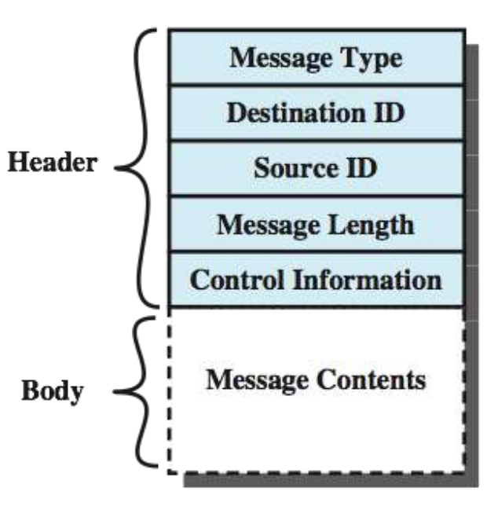

* + - * + **Header**

Contains information about the message

Who sent it?

Who is meant to receive it?

What type of message is it?

* + - * + **Body**

A block of bytes containing the message itself

As with shared memory and streams, it is up to the programmer to structure the attached data in a sensible way

* **Concurrency Implications**
  + **Synchronizing Processes with IPC**
    - Stream based IPC (pipes, etc.), as well as sockets, etc. provide enforcement of FIFO behaviour between readers and writers
      * Together with message queues, they shared the following important policy:
        + **Data can never be received before it has been sent!**
    - As such, they can be used for synchronising concurrent processes (i.e. as a tool for mutual exclusion)
      * One process may block waiting to read from another process, indicating that it is safe to proceed
      * The kernel guards access to the IPC resource to enforce mutual exclusion without the need for programmers to use semaphores / mutexes
  + **Indirect Process Communication**

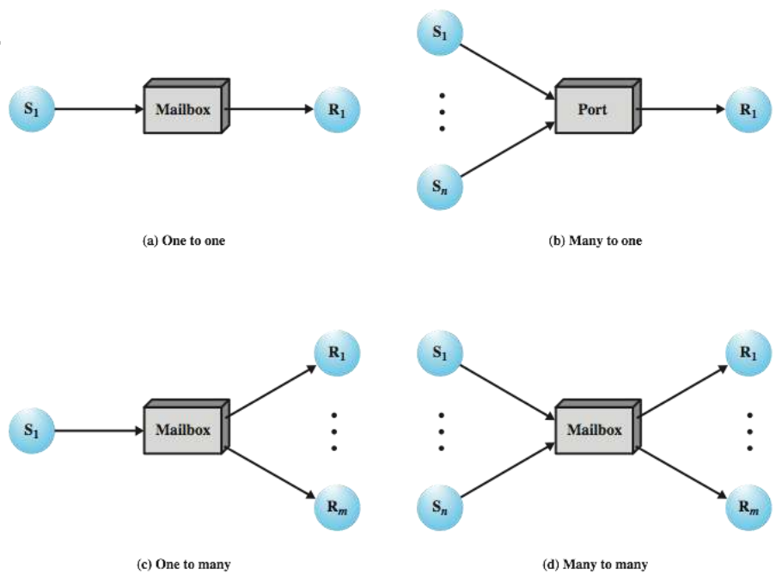

* + - For IPC mechanisms such as pipes, sockets, and message queues, all data must go through the kernel.
      * This slows things down a little, but enables the kernel to enforce concurrency protections.
  + **Shared Memory?**
    - Shared memory does not pass through buffers in the kernel, it is simply a virtual memory segment that multiple processes may access at any time
    - Additional synchronisation locks (semaphores, mutexes) are needed when dealing with shared memory to prevent race conditions

# Week 12 - OS Security

* System threats fall into two main categories:
  + **Intruders** - unauthorised access to a system by a user
  + **Malicious Software** - viruses and other forms of malware which may be present on the system
* **Intruders**
  + An intruder may be an unauthorised person trying to access a system, or a software bot simulating a user
  + **Authentication**
    - A system of verifying that the user is authorised to access part of a system
      * Username is **public** information, and the password is a secret known to the authorised user
    - **How does the file system help?** 
      * Each file in a Unix filesystem contains a UID (user ID) - each user on a Unix system has a unique UID
        + These UIDs (and GIDs for shared files) apply a set of permissions to files
        + UIDs are also attached to each process on the system (stored in the PCB)

Forked processes inherit the same UID

* + - * When a process tries to open() a file, the kernel checks the process UID against the file UID
        + If the file and process have the same owner (or the file permissions allow), the system call is allowed to complete
      * **Design Flaws** 
        + Many file systems (e.g. FAT) do not support UIDs
        + When moving physical memory devices between systems, the UIDs will be different

The file will appear to belong to a different user on the other system

In the 1970s, the idea of moving a hard drive from one machine to another was unthinkable

* **Malicious Software - Malware**
  + **Types of Malware**
    - **Viruses**
      * Cannot exist outside of some application, utility, or system program
        + e.g. fragment of malicious code that has become embedded within a legitimate program
    - **Independent (Worms, Bots, Trojans)** 
      * A malicious utility that can be scheduled and run by the OS
    - **Replicating**
      * Viruses or programs that produce copies of themselves
  + **How does Virtual Memory Help?**
    - **Case 1 - A Virus Attempts to inject Arbitrary Code into a Process Image**
      * Pages or segments containing executable program code are read-only
        + The VM system marks entries in the page / segment table as read-only if they are allocated to executable machine code
        + Even if a program is compromised by loading malicious data, the program could not re-write its own executable instructions
    - **Case 2 - Malicious Program attempts to snoop on other processes**
      * The VM system ensures that the logical address space of one process does not permit access to the logical address space of another, unless they deliberately use shared memory
* **What about IPC?**
  + *A client process could exploit a vulnerability in a server process*
    - **Buffer OverFlow Attack**
      * A client process connects to a server process, then floods it with invalid data designed to exploit the receiving buffer
      * Aim is to overwrite other variables in the server; thereby modifying the server’s behaviour
    - **Unauthorised Clients**
      * A client process might not be what it claims to be - a server written to ‘trust’ a connect client may open up a security hole
        + e.g. server process may be running as root, giving a client access to the file system
  + **Example - Native Desktop (X-Window System, Linux)**
    - The traditional display server utility used in many Linux desktop environment
    - Allocates a unique Window ID (WID) to each window on screen
    - To read or modify text or graphics in a window on the screen, a client application passes its WID to the display server
      * The X-Window system does not check *which* process is requesting access to the particular wid
      * Any process can therefore access any other process window and it’s contents freely
    - **Lessons Learned?**
      * Even if the OS is secure by itself, insecure utilities open vulnerabilities, and most commonly by accepting connections through IPC mechanisms
      * **What can we do to resolve this?**
        + Run server processes with a special user account that does not give access to sensitive files
        + Write utility applications carefully so they are not vulnerable to security threats

*Authenticate new connections, validate incoming data*

* **Operating Systems in Decay**
  + All products have a limited lifespan
  + **Maintenance Factors**
    - **Design Rot**
      * Any piece of software becomes more complex over time.
      * If a problem with an OS is due to the design of the OS, it might not be feasible to re-design the OS in such a way that it fixes
        + Quick patches make the design less clear and lead to more design patches
      * Updates intended to fix security issues generally make the OS too complex
        + As the OS becomes too complex, the working of the OS itself can no longer be easily scrutinized, and eventually lose the trust of users
  + **Business Factors**
    - **Dark Patterns**



* + - * When the design of the system becomes focused on the vendor goals rather than needed functionality
        + Repeatedly interrupt the user to prompt them to carry out the task that does not benefit
        + Hiding access to desirable options
    - **Built-In Obsolesence**
      * Changes are implemented for the sake of making changes - less innovation, more ‘keeping up appearances’
      * A system may be changed to deliberately break compatibility with existing software
        + Users may be left with no alternative to change to a newer system